1. ERU Requirements
2. General Summer Research
   1. Batteries and Motors
   2. PCB
   3. Sensor and Motor Driver
   4. Power Board
3. Subsystem Specific Research
   1. Battery Management System (BMS) Team
   2. Regulator Team
   3. PCB Team
4. General Architecture Overview
   1. Mock SRR Slides
   2. Final SRR slides
   3. General Block Diagram and Revisions
5. Block Diagrams for PCB Concepts
   1. BMS Block Diagram
   2. Power Board Block Diagram
   3. Signal Shields Block Diagram
6. Voltage Regulators Board
   1. Version 1: Schematic, PCB design and 3D model
   2. Version 1: Testing/results
   3. PCB Design Review Notes
   4. Version 2 (with changes): Schematic, PCB Design, and 3D model
   5. Version 2: Testing/Results
7. Battery Management System Board
   1. Schematic, PCB Design and 3D model
   2. Testing/results
8. Power Board
   1. Version 1: Schematic, PCB Design and 3D model
   2. Version 1: Testing/results
9. Signal Shields
   1. Version 1: Schematic, PCB Design and 3D model
   2. Version 1: Testing/results
10. Preliminary Design Review (PDR)
11. Final Build and Test
12. ERU Requirements

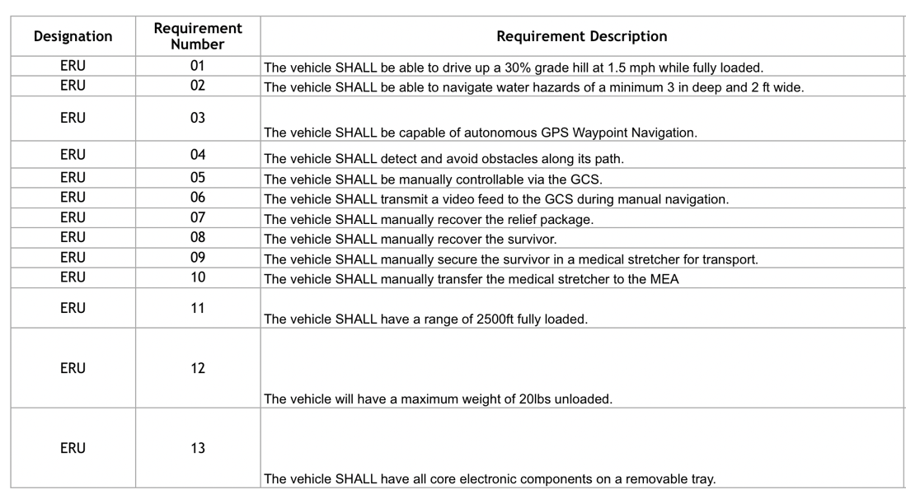(given to the team in October 2023)

2. Summer Research

Each person was tasked with doing research on the different topics that the electrical team had done in the previous year, as well as add on further research to it as well. This was done since this year would essentially be an extension of what had been done the previous year, so understanding what foundations they stood on was important.

2.1 Batteries and Motors

**Batteries** By: Sam Fowler

Types of Batteries and Characteristics

* Lithium Ion – has high power density, low self-discharge rate, degradation over time, little to no maintenance, medium thermal operation range, and generally pretty safe to use. Around 3.6V
* Lithium Polymer – higher specific energy than lithium ion, high discharge rate, degradation over time, needs more maintenance, smaller thermal operation range than lithium ion, and less safe. Around 4.2V
* NiMH – lower energy density, medium discharge rate, degradation over time, occasional maintenance, larger thermal operation range, and generally pretty safe to use.
* NiCad – lowest energy density, medium discharge rate, degradation, require maintenance often, larger thermal operation range, and less safe.

* Power Density – rate at which the battery delivers energy
* Discharge Rate – how quickly a battery releases stored energy
* Degradation – loss of capacity/performance over time
* Maintenance – ensuring that the battery is at optimal performance and lengthening lifespan
* Thermal Operation Range – the optimal temperature range that a battery can be safely and efficiently operated at
* Safety – how safe battery is to handle and what the risk is of fire, explosion, or hazard to user

Battery Voltage and Capacity

* Battery voltage – potential difference
* Battery capacity – amount of energy a battery can store and deliver

WFT Equation

* Watt – Hour / Foot = (Motor Amp * Motor Voltage) / Motor Speed
* Distance = (Battery Voltage * Battery Capacity) / Watt – Hour/ Foot
* Relates the distance a specific motor can travel given battery capacity

**Motors**

* DC Brushed – low cost, medium speed, medium efficiency, short lifespan, low max speed
* DC Brushless – medium price, high speed, higher efficiency, longer lifespan, must be connected to controller.
* Servo – high cost, high response, steadier against load changes
* AC – low efficiency, high power consumption, high torque, longer lifespan
* Stepper – high efficiency, long lifespan, high control
* Gear – high torque, low speed

* RPM – high RPM for applications that need speed
* Weight – low weight needed for mobility and system efficiency
* Maintenance – lower maintenance means less upkeep
* Power Consumption – low power consumption good for power efficiency
* Size – a smaller size preferred for space constraints

* Motor amperage – amount of current the motor draws and turns into mechanical output
* Motor voltage - provided by a battery, operating voltage
* Motor Speed – converted from RPM into mph or m/s

Batteries by: David Wong

Types:

1. Lithium Ion  
   This type of battery has a high power density, but a slower rate of discharge than some of the other battery options. These batteries also require protection during charging, meaning that they must not be overcharged or fully discharged. If the cell is overheated or overcharged, the cell will degrade much faster. There is also no need for active maintenance because there is no memory loss effect.
2. Lithium Polymer  
   This battery uses a liquid polymer instead of a liquid electrolyte as in the lithium ion. This gives it a higher special energy than its counterpart. It is also a more lightweight battery option. These batteries, however, are also more prone to expansion when overcharged.
3. NiMH
4. NiCad

Battery Voltage and Capacity:

The voltage of a battery cannot be actively measured during use but is rated with a nominal voltage. This means that the rated voltage is actually the open circuit voltage that the battery is able to provide. Most battery cells can provide around 2V of nominal voltage and the cells are linked in series to increase the voltage output on larger rated batteries. The battery also has a cut-off voltage which is where damage will begin to take place if the battery is discharged any further.

Battery capacity is usually measured in Amp-Hr, Watt-Hr, or kiloWatt-Hr and is derived from the amount of active material that the battery contains. It represents the max energy that can be pulled from the battery when under specific conditions, though age and consistent use will affect this value. Another thing that affects the capacity is the rate of charge/discharge, as higher rates of discharge will result in a lower capacity.

2.2 PCB

PCB research by Cuauhtemoc Lona

Signal Board:

-the board contained:

* 2 L298N Motor Drivers, all having four connectors (labeled H7 and H6)
* BTS7960 Motor Driver, 2 connectors (Labeled H8)
* 4 Distance sensors, each having 2 connectors (Labeled H2-5)
* A 2 geared motors (platform rot and mircometal), both having 2 connectors (Only H12, mircometal was not used)
* 6 light switches, one pinout (H14, only 4 were used)
* And more

Here is the signal board used:

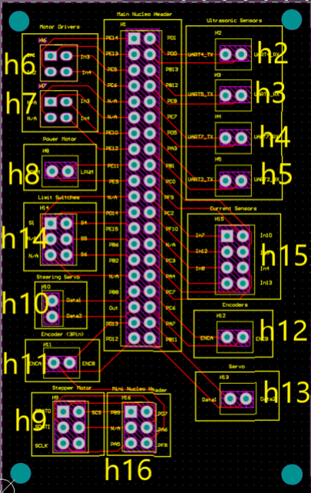

The board is

Wiring/connectors:

Each component had a listed header, wire color used, component number, and more. All necessary for any reforms or reviews.

Each being color coded as well for easy readability as well as a brief description of how much voltage each device needs.

Some connectors used were:

Terminal blocks like the XT30 and XT60 to connect the battery to the PCB. The XT60 was, as of last year, the better option because of the higher amperage of 60A max.

Also, the JST 2 pin wire was an option to connect the components to the PCB, having both male and female connectors.

Other components needed were Raspberry Pi 4, NUCELO-F767ZI, MTi-680G RTK, H

2.3 Sensor and Motor Drivers

Specs to look for when choosing DC motor by Ruben Banzon

* + Motor voltage – voltage the motor operates at, and driver should handle it
  + Avg current – amount of current the motor consumes on normal load conditions
  + Stall current – amount of current motor will draw if shaft is seized or held in place. Motor driver needs to have a peak current capability to handle it
* Motor Driver
  + Inserted bet power source and the motor
  + Allows signals from microcontroller to control speed and direction
* H Bridge Configuration
  + Controls speed and direction of DC motors
  + There are 4 switches
    - Closing 2 switches spins the motor clockwise/counterclockwise
    - These “switches” are Bipolar transistors or MOSFETS
    - Bipolar transistors have voltage drop of 0.7v for each transistor (1.4v total) and requires large heatsinks
    - MOSFETS are more efficient. Total voltage drop is about 0.2v and most design do not require heatsinks
* Pulse Width Modulation (PWM)
  + Controls the speed of the motor
  + Allows slower speed with full torque
  + Increasing the width makes the rotation of the motor faster (frequency stays the same)
  + Low state turns off the motor
  + High state – motor will be in full speed (not recommended over 98% speed)
* 3 methods of controlling speed and direction
  + PWM Input + control lines

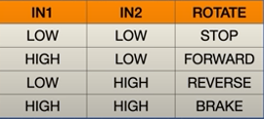

* + PWM + 1 Control (simplest)

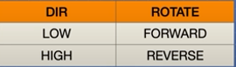

* + 2 PWM (most popular)

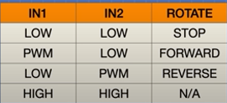

IBT-2 BTS7960 H-Bridge

* + Single channel H-bridge driver
  + Motor Voltage – 6 to 27v
  + Continuous Current – 30A
  + Peak current – 43A
  + Logic Voltage – 3.3 to 5v
  + Consist of two H bridge chips

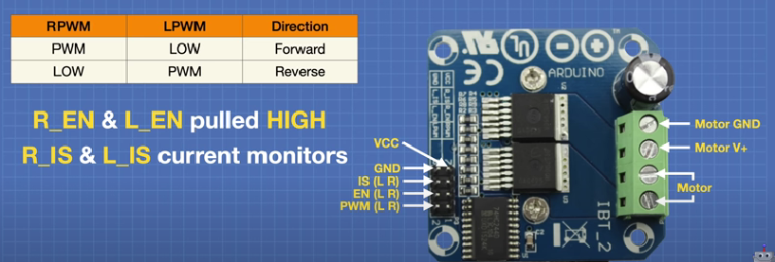

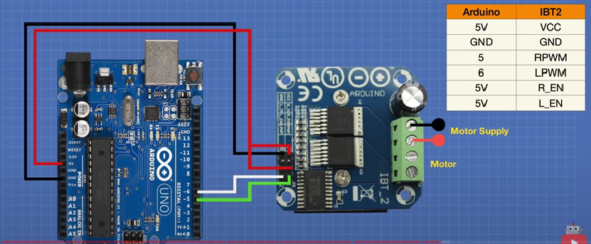

L298N Motor Driver

* Can control speed and direction of 2 DC motors
* Can control bipolar stepper motor
* Uses PWM signal to control speed
  + Higher Duty cycle increases motor speed
  + Shorter duty cycle decreases motor speed
* Uses H-bridge to control direction
  + Closing 2 specific switches at the same time reverses the polarity of the voltage applied to the motor, changing the direction it spins
* Contains H-bridges
* Motor output voltage – 5 to 35v
* Motor output voltage (recommended) - 7 to 12v
* Logic input voltage – 5 to 7v
* Continuous current per channel – 2A
* Max power dissipation – 25W

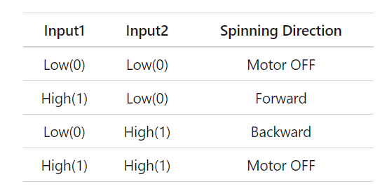

Pololu High-power stepper motor driver 36v4

* A discrete MOSFET stepper motor driver
* Combines DRV8711 stepper motor driver IC from Texas instruments with external MOSFETs
  + DRV7811 uses N-channel MOSFET
* Controls one bipolar stepper motor
* Specs:
  + Maximum current only with additional cooling (heatsink or forced air flow)

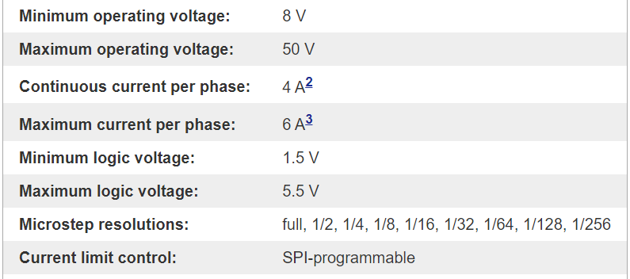

* Highly configurable through SPI Interface
* 9 different step resolutions down to 256 microsteps available
* Adjustable current lets us set max current output, enabling the use of voltages above the stepper motor’s rated voltage for higher step rates
* Adaptive blanking time, adjustable decay times, and various current decay modes for ultra smooth motion profiles through SPI interface
* Stall detection
* Supports alternate operating mode for controlling two brushed DC motors with PWM inputs
* Arduino library available for basic functions for configuring and operating the driver

US-100 ultrasonic Distance Sensor

* Input Voltage - 3-5v
* HC-SR04 mode
  + Uses this mode when the jumper on the back is removed
  + Acts like an HC-SR04 with a trigger and echo pin
* Serial UART mode
  + Uses this mode when jumper is in place
  + Use 9600 baud UART to communicate with the sensor
* Range 2cm to 350cm

2.4 Power Board

**Power Board by Clisbert** Hurtado-Hernandez

Crosstalk

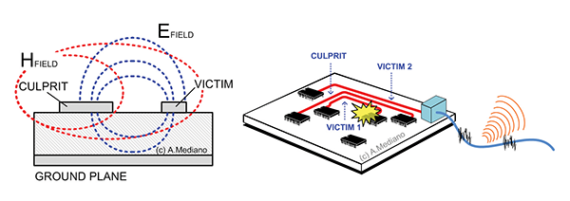

Transmission of signals and noise due to coupling between lines, and is also called interference (usually an undesired effect when one component affects the other) [1]

* This can occur on PCBs when traces are not spaced sufficiently (electromagnetic); adjacent traces are placed on the same layer.
* Increased frequency induces coupling (inductive or capacitive) on adjacent signals (causes crosstalk).
* As shown in the figure above, magnetic or electric field lines come from the culprit trace and impact the victim trace [2].

Prevention techniques:

* Maintaining spaces between traces that run high-speed signals.
* Try to isolate high-frequency signals (especially clock signals) from other traces. Also, isolate asynchronous signals away from high-frequency signals and closer to power lines or signals that control on and off.
  + Separate groups of nets according to their signal amplitude (prevents large voltage nets (3.3V from affecting smaller voltage nets (1.5V)).
* Maintain space between traces that carry high-speed signals. Rule of thumb: Interpose between adjacent traces at least 3 times their width.
* If parallel traces cannot be prevented, keep their width as short as possible.
* Couple the return path to the ground with the high-frequency signal.
  + Since the return path is equal in magnitude but opposite in direction, the fields cancel out and reduce crosstalk.
* Differential signaling: two signal lines with the same amplitude and opposite polarity form a single high-speed signal.
  + They must be equal in length and routed symmetrically close to each other as much as possible.
* Additional rules for 2+ layered boards
  + If traces are on multiple layers, make sure to alternate the direction of traces on adjacent layers to prevent having parallel traces.
  + Insert a ground plane /power plane between adjacent layers to reduce broadside coupling and increase the distance between layers.

(These are for average values used)

Forward vs Backwards Crosstalk [3]

Connectors

Power Connectors

* XT- connectors for battery to PCB
  + XT60 uses lower gauge == thicker wire, therefore more current can run through
* XT60 M-F connector works as it is 12 gauge (will work for soldering)
* JST 2-pin Right Angle Connector
* Molex 51021 2-Pin

Wires

* Possibility we would want something closer to more modular connection types
* 22-gauge
* 13-gauge for higher amperage

Parts List (#17 and 18)

5V, 5.5A Step-Down Voltage Regulator

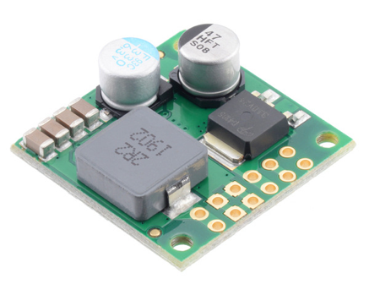  
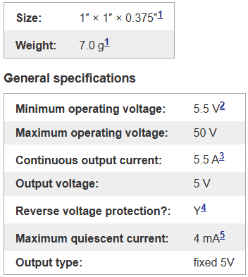

1. Without included optional headers.
2. Subject to dropout voltage considerations. See the dropout voltage graph under the description tab for more information.
3. Typical continuous output current at 36 V in. Actual achievable continuous output current is a function of input voltage and is limited by thermal dissipation. See the output current graph under the description tab for more information.
4. To -40 V. Connecting supplies over 40 V in reverse can damage the device.
5. While enabled with no load. Can be reduced to under 1 mA using the enable pin.

3.3V, 6.5A Step-Down Voltage Regulator

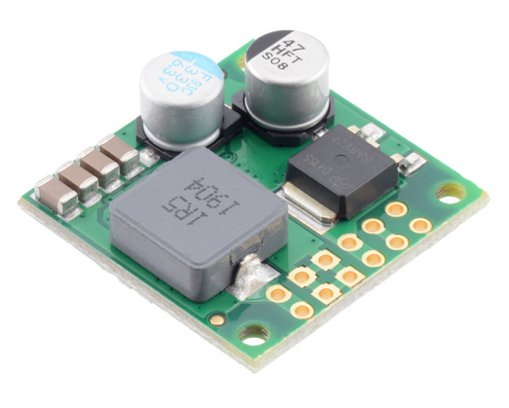

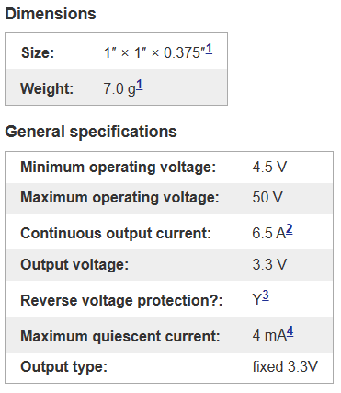

Notes:

1. Without including optional headers.
2. Typical continuous output current at 36 V in. Actual achievable continuous output current is a function of input voltage and is limited by thermal dissipation. See the output current graph under the description tab for more information.
3. To -40 V. Connecting supplies over 40 V in reverse can damage the device.
4. While enabled with no load. It can be reduced to under 1 mA using the enable pin.

Previous Year’s Design  
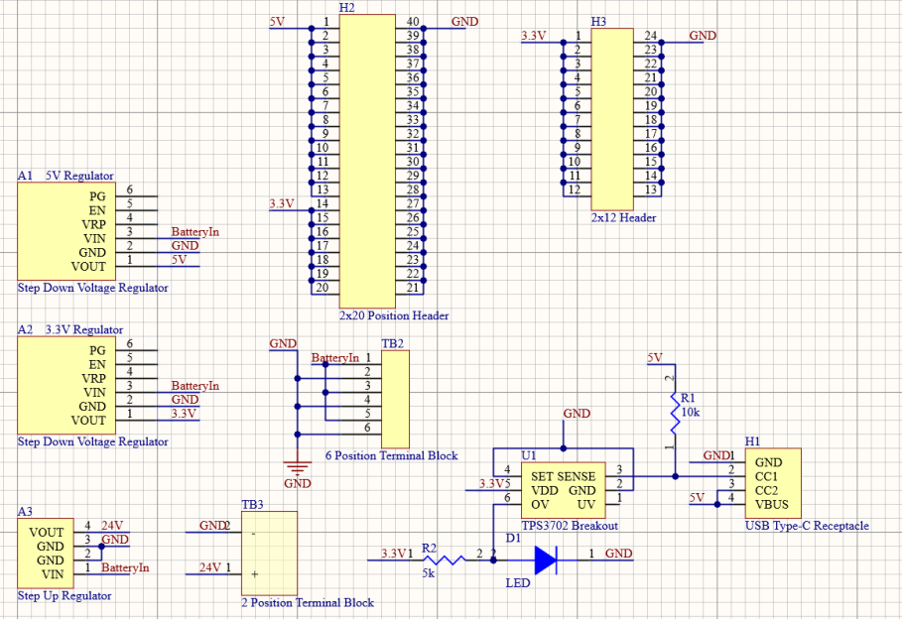

Points of Interest

* 5V Regulator
* 3V Regulator
* Input Voltages for H1, H2, H3, and U1
  + Output voltage for regulators are inputs for H and U

[1] <https://www.protoexpress.com/blog/crosstalk-high-speed-pcb-design/>

[2] <https://incompliancemag.com/article/visualizing-crosstalk-in-pcbs/>

[3] <https://www.protoexpress.com/blog/crosstalk-high-speed-pcb-design/>

3. Subsystem Specific Research

Research that each team found relevant to the success of their goals.

3.1 Battery Management System (BMS) Team

* The goal for the first version of the UGV’s BMS was for it to accurately measure the lipos voltage and capacity
  + One BMS team member wanted to implement the same technique that he saw on a previous project. This involved using a simple voltage divider circuit to calculate the voltage.
  + The capacity would be calculated by correlating the voltage readings with the max and min battery voltage.
* The ATMega32P was selected as the systems MCU due to having ADC pins, I2C communication and a user-friendly IDE.

3.2 Regulator Team

Switching regulator fundamentals  by Marilyn Hernandez

* Buck – used to reduce a DC voltage to a lower DC voltage
* The law of inductance
* V = L (di/dt)
* Two important characteristics
* A voltage across an inductor results only from current that changes with time. Steady DC current through an inductor causes no voltage across it.
* Current flowing in an inductor can’t change value instantly. Faster current change in an inductor means larger resulting voltage
* Voltage in inductor can change instantaneously
* 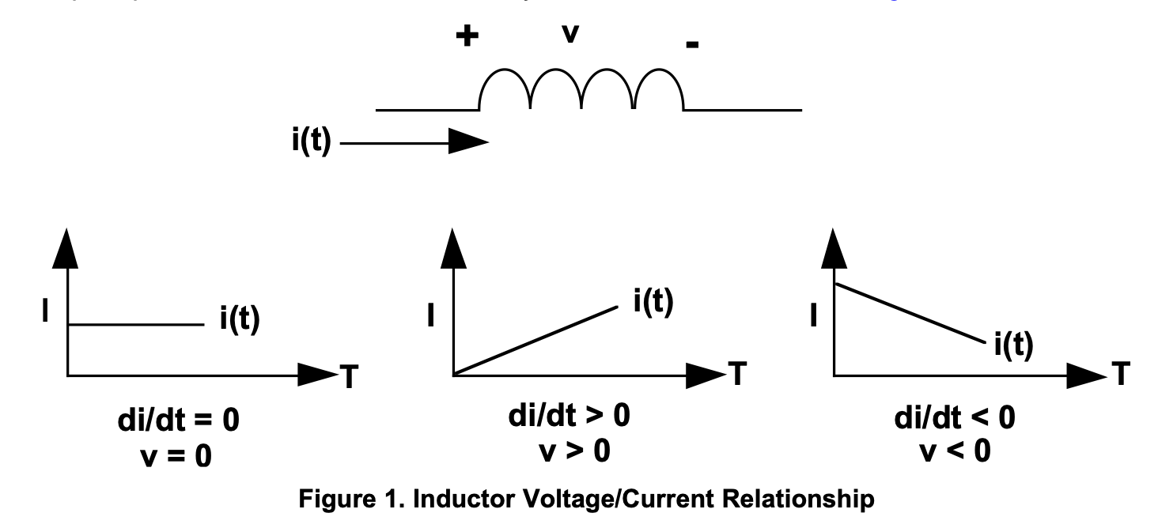
* Left: constant current, no voltage, middle:  current increase, positive voltage, right: current decrease, negative voltage
* Only constant current ramp when constant voltage across it
* Transformer Operation
* Transformer: device that has two or more magnetically-coupled windings
* 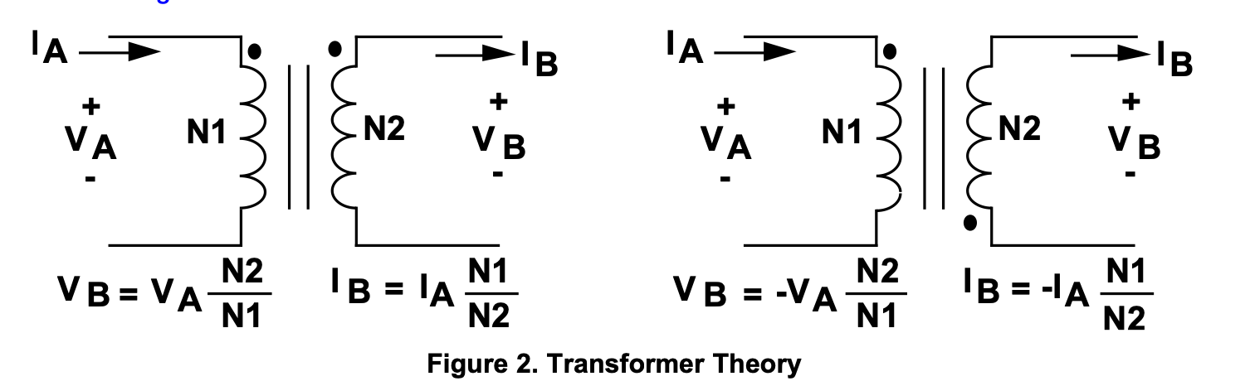
* How it works
* Time-varying (AC) voltage or current is transformed to a higer or lower value, as set by the transformer turns ratio
* Winding with more turns has higher voltage but lower current and windings with less turns has lower voltage but higher voltages because it follows the power equation on either side
* Pulse Width Modulation (PWM)
* Switching converters in paper use a form of output voltage regulation known as PWM
* Simply, a feedback loop adjusts/corrects the output voltage by change the on time of the switching element in the converter
* Output voltage can be directly controlled by changing the on time of the switch
* Buck converter
* Uses a transistor as a switch that connects and disconnects the input voltage to an inductor
* 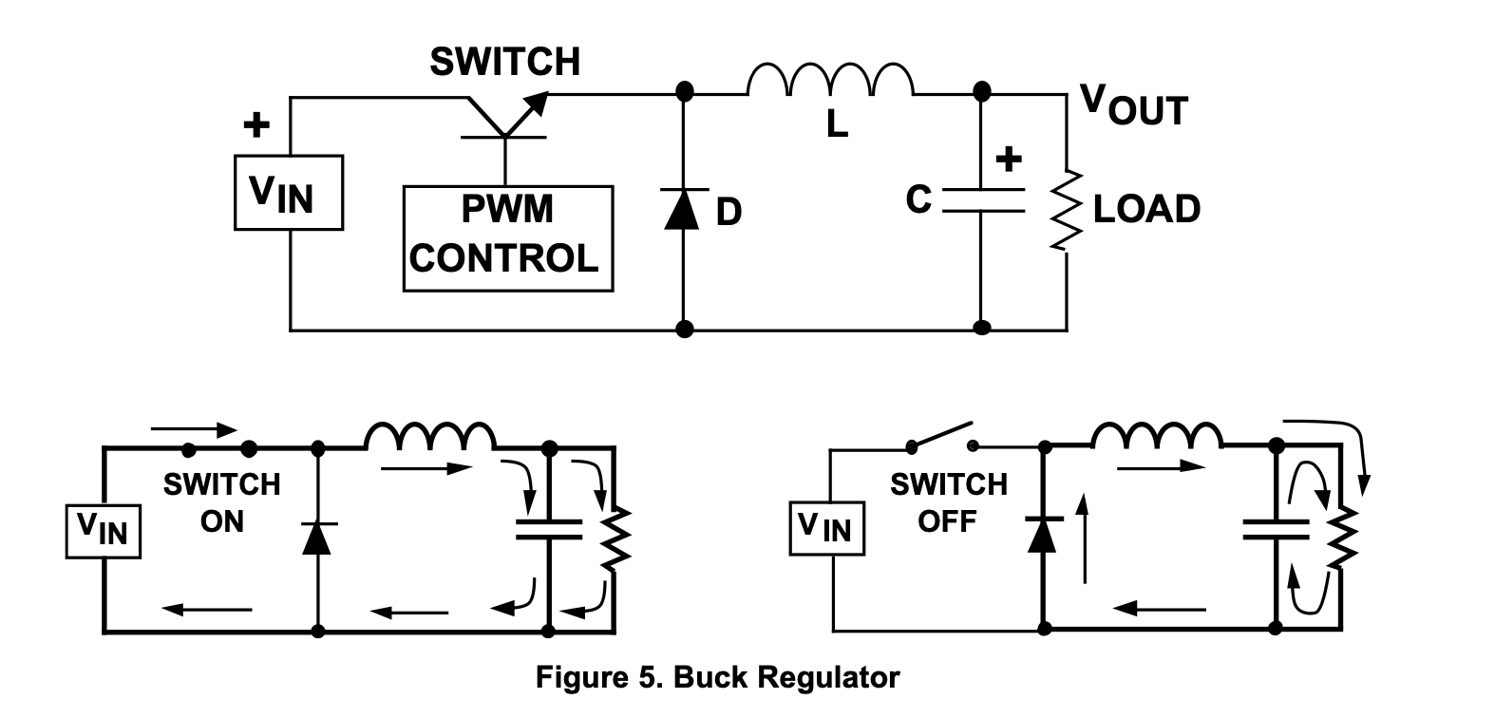
* Switch on
* Difference between input voltage and output voltage is forced across the inductor causing the current through the inductor to increase
* The inductor current flows into the load and the output capacitor (the capacitor charges)
* Switch off
* Input voltage applied to inductor is removed
* Current in inductor can not change instantly, so voltage across inductor will adjust tto hold constant current
* Input end of inductor is forced negative by deceasing current
* Reaches point where diode turns on
* Current flows through load and back into diode
* Cap discharges into load during off time, contributes to total current supplied to load (sum of inductor and cap current)
* Current flow through inductor
* 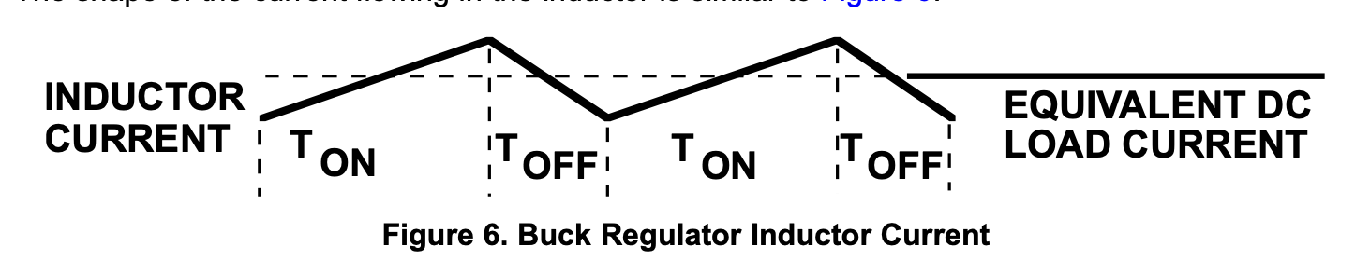
* Current through inductor ramps up when switch is on and ramps down when switch is off
* DC load current from regulated output is average value of the inductor current
* Inductor is typically selected large enough to keep the ripple current less than 20% to 30% of the rated DC current
* Application Hints

DC to DC Buck Converter Tutorial & Diagram

* Abstract
* Different types of switching regulators used in DC-DC conversion
* Reviews and compares the control techniques for these converters
* Introduction
* Inductors function
* Limit the current through the power switch
* Limits high peak current that would otherwise only be limited by the resistance
* Inductor stores energy
* Linear regulator
* Uses a resistive voltage drop to regulate the voltage
* Loses power in the form of heat
* What is a switching regulator?
* Definition: is a circuit that uses a power switch -> an inductor and a diode to transfer energy from input to output
* Step-down (buck) converter
* 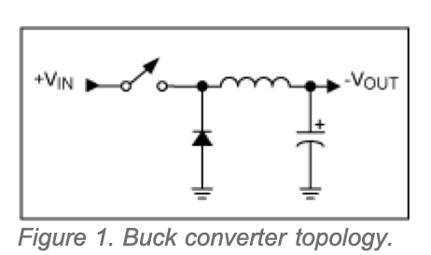
* Step-up (boost) converter
* 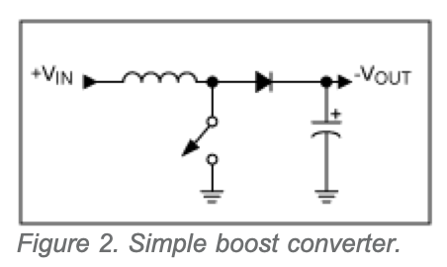
* Why use a switching regulator?
* Switch regulator versus linear regulator
* Switch reg
* Switching efficiency is better, less energy lost in the transfer, less thermal management
* Energy stored in inductor can be transformed to output voltage that can be greater than the input or can be transferred through a transformer to provide electrical isolation
* Switch regulators can be noisy and require energy management in the form of control loops through switch-mode controller chips
* Linear regulators provide lower noise and higher bandwidth
* Low Power POL Buck Converter
* MAX1836/MAX1837 high efficiency buck converters
* Preset 3.3V or 5V output voltage from supply voltage as high as 24V
* With external feedback resistors the output can be adjusted from 1.25V to VIN
* Delivers load current up to 125mA or 250mA
* NanoPower Buck Converter
* Operating from 1.8V to 5.5V input voltage
* Supporting loads of up to 175mA, 350mA, 700mA

Research by Clisbert Hurtado-Hernandez

Since we do not need to design a DC-DC regulator from scratch anymore, we are looking for off-the-shelf consumer regulators that we can buy. Some that I found particularly interesting:

Recall:

* Linear Voltage Regulators: These are simple and inexpensive voltage regulators that operate by using a voltage-controlled device to drop the input voltage to a desired level. The primary disadvantage of linear regulators is their inefficiency, especially at higher voltage differences between input and output, as the excess power is dissipated as heat.

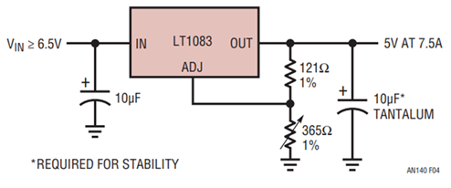

* Burns a lot of power
* Large heat sinks are needed (How does stability work?)

* Switching Voltage Regulators: More efficient than linear regulators, these use a high-frequency switching element like a transistor to convert the input voltage. They can step-up, step-down or invert the input voltage, making them versatile. However, they are more complex and can generate more electrical noise due to the switching action.

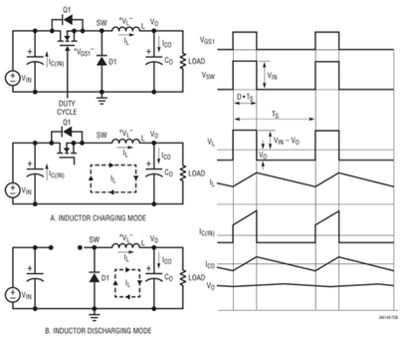

*Integrated Circuit Voltage Regulator:*

* Linear Voltage Regulators: These are the most commonly used type of voltage regulators. Linear voltage regulators operate by dropping the input voltage to the desired level using a transistor in active mode.
* **Switching Voltage Regulators:** Unlike linear regulators, switching regulators use a switch to control the flow of energy from the input to the output. These are more efficient than linear regulators but can cause more electrical noise.
* Series Voltage Regulators: In these regulators, the regulating device is in series with the load. They have the advantage of a very steady output.
* Shunt Voltage Regulators: Here, the regulating device is parallel to the load. They offer better control but can waste more energy.

3.3 PCB Team

None was really done, made designs under Aaron’s guidance and feedback.

Some general things that Aaron wanted the team to keep in mind:

* Switching Regulators
  + Wide traces for switching and output nodes
  + Keeping loop of switching node -> inductor -> output node -> ground, as small as possible
  + Input filtering capacitors as close to regulator IC as possible (and in general for ICs)
* Signal Shields
  + Ground planes on top and bottom layers to give signals an easy return path to go, instead of interfering with other traces
  + Orthogonal routing when crossing traces on different layers, less interference that way
* Power Boards
  + Big planes to dissipate high currents

4. General Architecture Overview

This section includes slides for System Requirements Review (SRR) and the general block diagrams at various stages of the project. SRR was significant because it set a deadline for leads to establish the overarching design and goals that the team had to meet. Block diagrams showed off the leads’ thought processes in how each part of the system came together.

4.1 Mock System Requirements Review (SRR) Slides

[Electrical 2023-2024 -> Project Reviews -> SRR -> mock srr slides](https://livecsupomona-my.sharepoint.com/personal/aodecastro_cpp_edu/_layouts/15/onedrive.aspx?FolderCTID=0x012000286121F72817F14EADB264D81B87BE51&id=%2Fpersonal%2Faodecastro%5Fcpp%5Fedu%2FDocuments%2FNGCP%20Electrical%2FElectrical%202023%2D2024%2FProject%20Reviews%2FSRR)

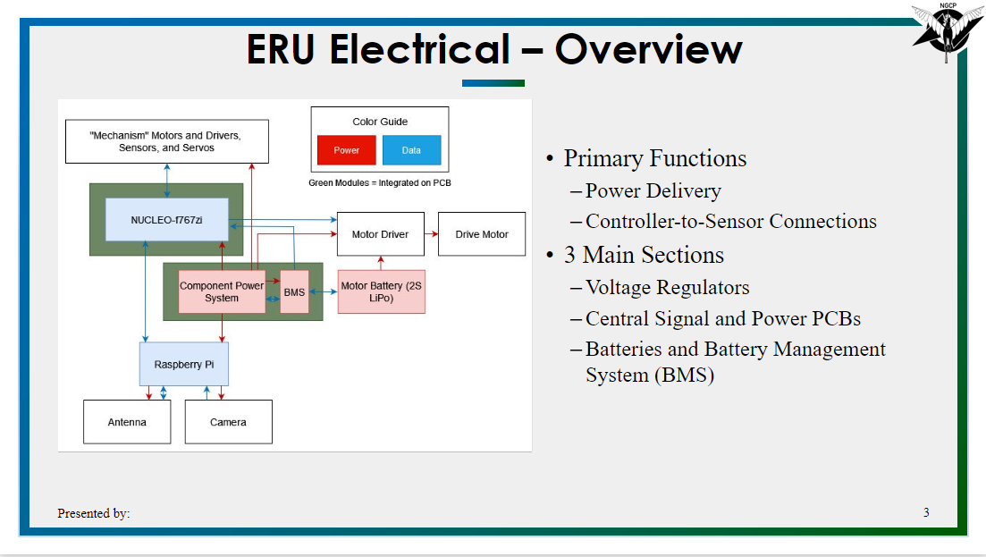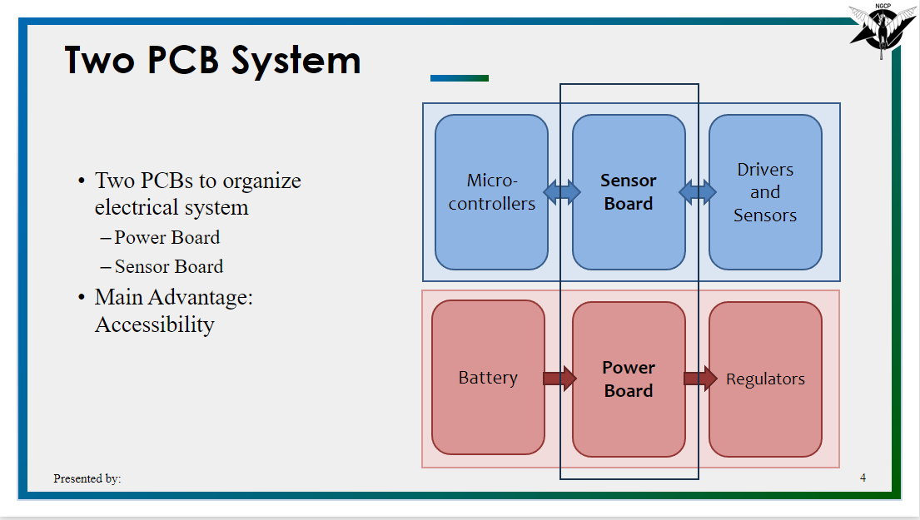

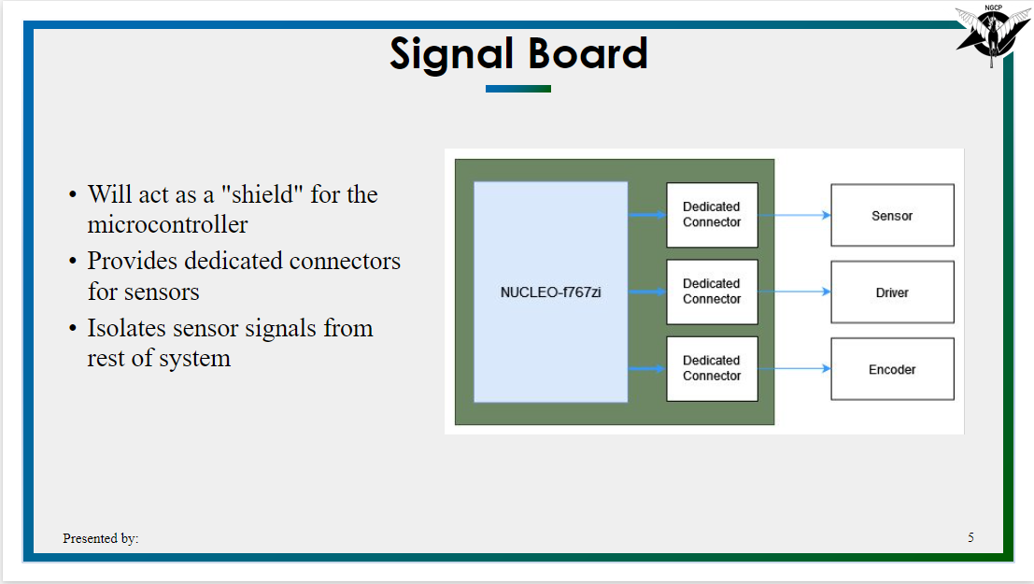

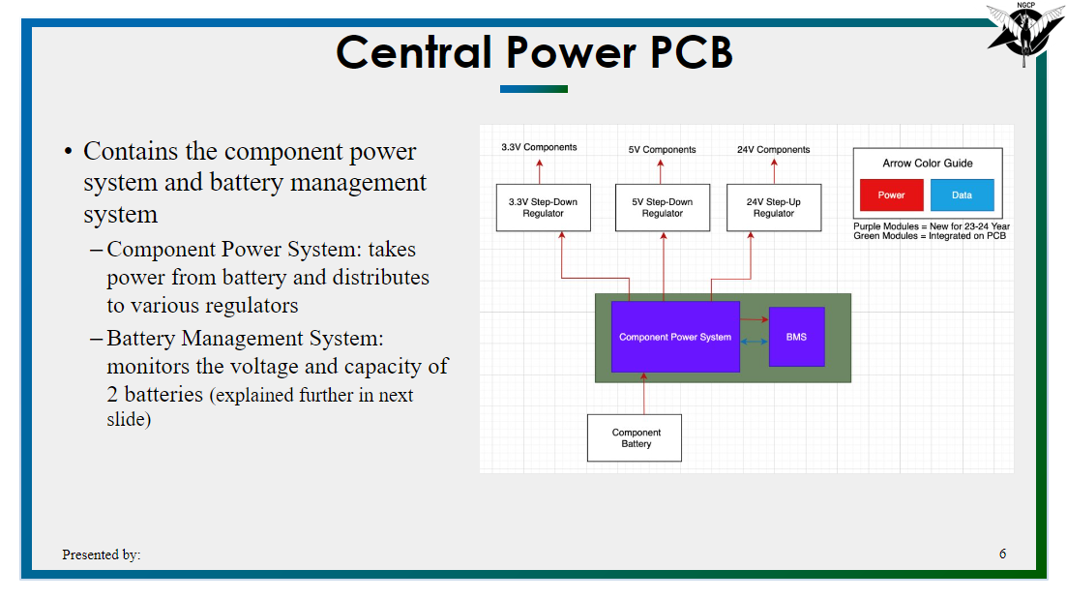

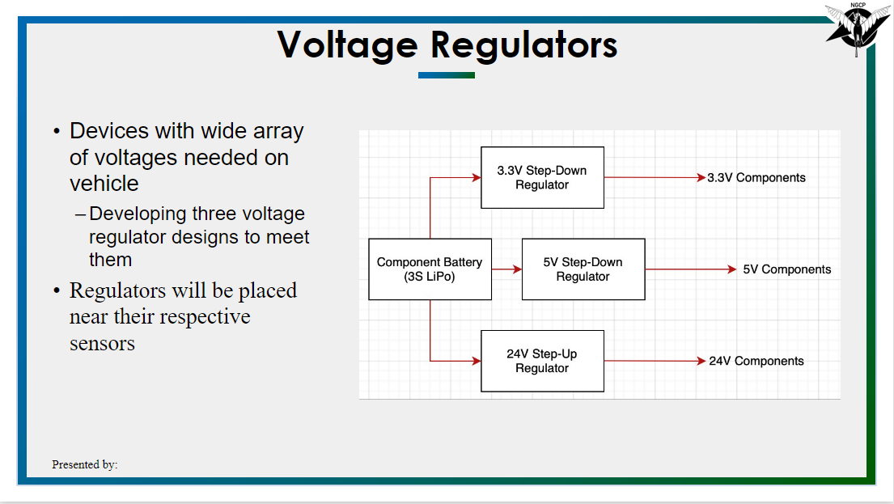

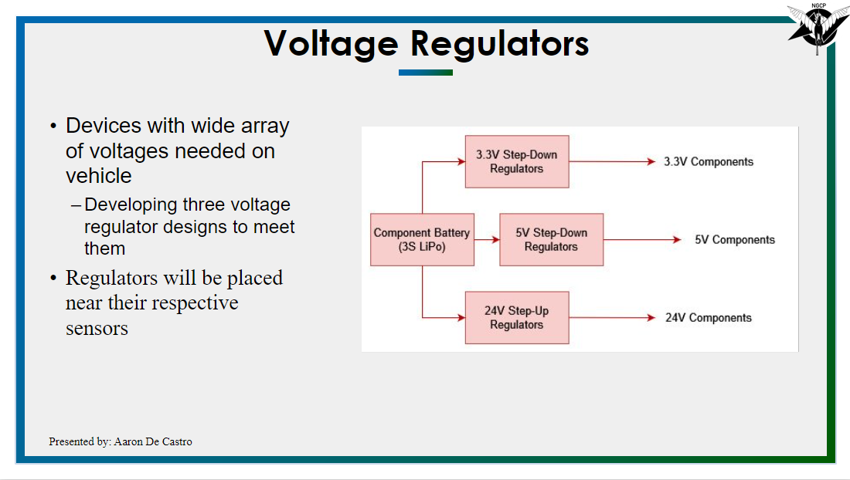

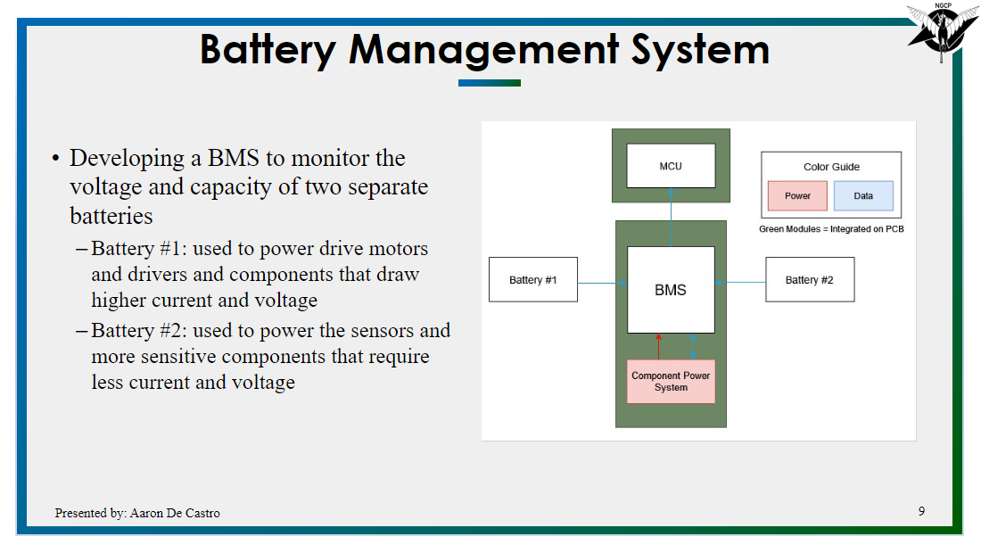

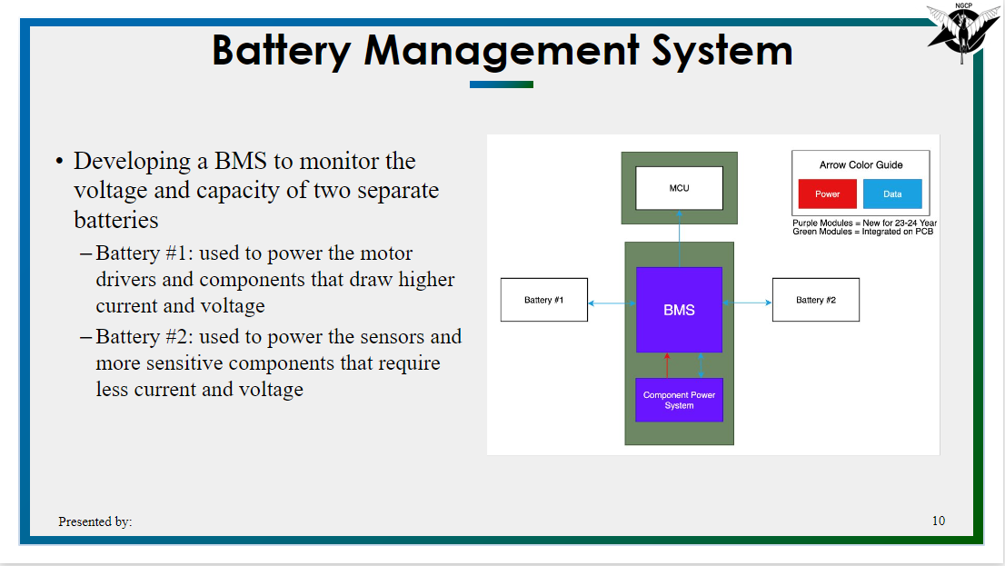

4.2 Final SRR Slides

[Electrical 2023-2024 -> Project Reviews -> SRR -> SRR_2023 Final (entire ERU) slide #102-105](https://livecsupomona-my.sharepoint.com/personal/aodecastro_cpp_edu/_layouts/15/onedrive.aspx?FolderCTID=0x012000286121F72817F14EADB264D81B87BE51&id=%2Fpersonal%2Faodecastro%5Fcpp%5Fedu%2FDocuments%2FNGCP%20Electrical%2FElectrical%202023%2D2024%2FProject%20Reviews%2FSRR%2FSRR%5F2023%5FFinal%20%28entire%20ERU%29%2Epdf&parent=%2Fpersonal%2Faodecastro%5Fcpp%5Fedu%2FDocuments%2FNGCP%20Electrical%2FElectrical%202023%2D2024%2FProject%20Reviews%2FSRR)

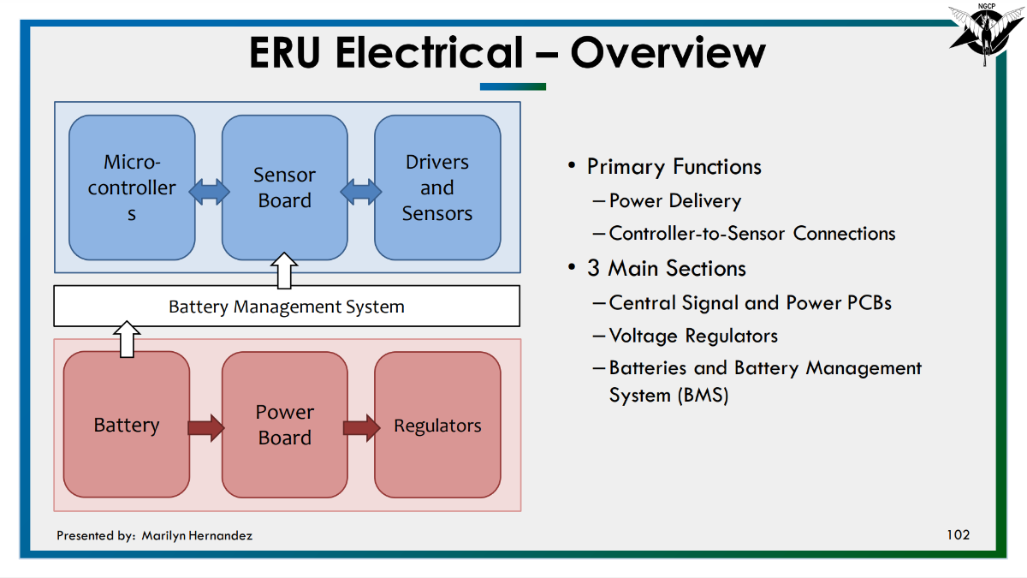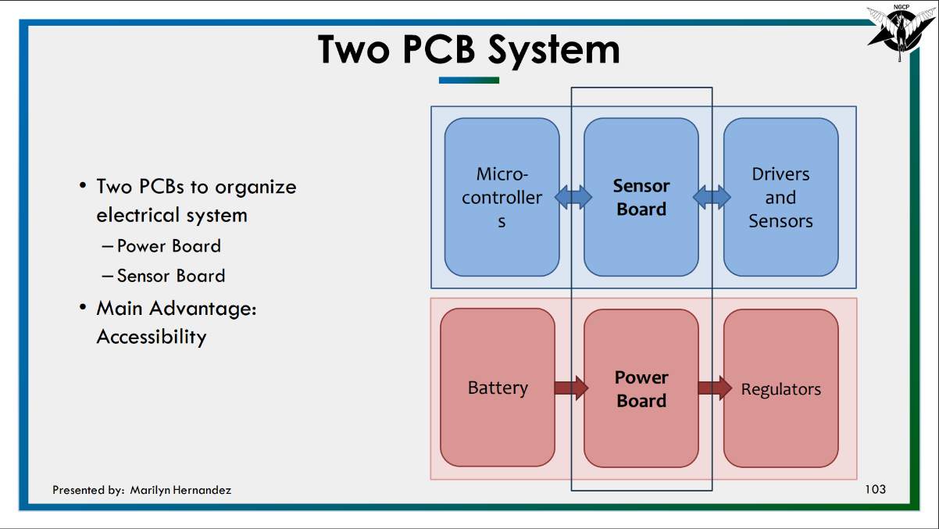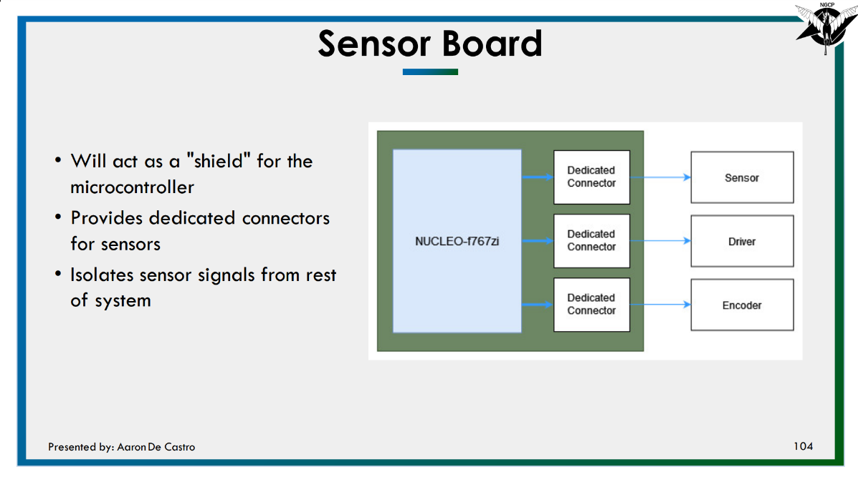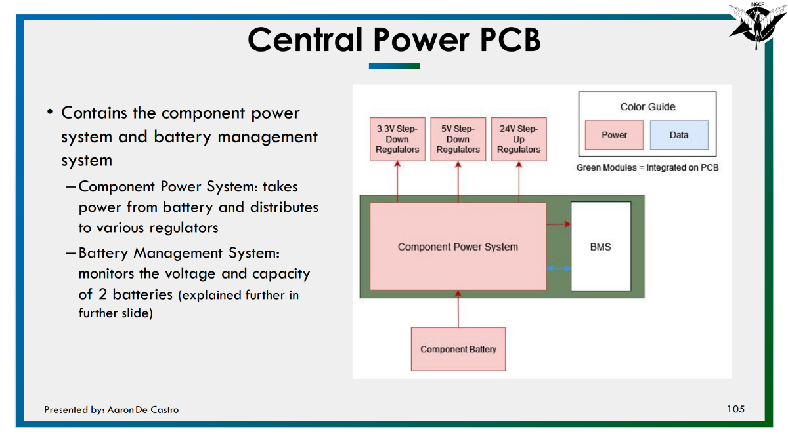

4.3 General Block Diagrams and Revisions

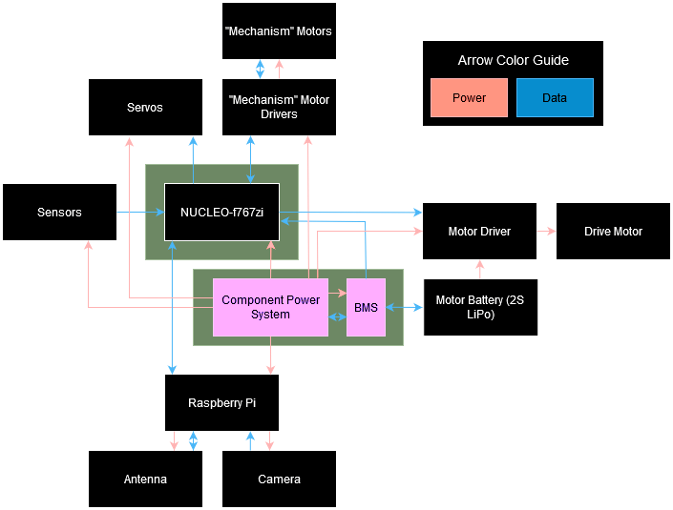

Overall System Block Diagram at time of SRR

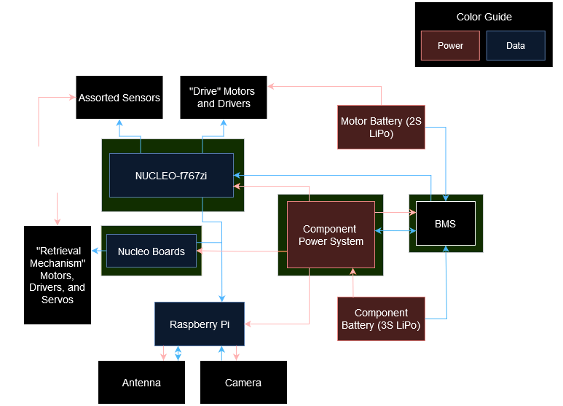

Overall System Block Diagram at the time of PDR

5. Block Diagrams for PCB Concepts

High level ideas of each of the main PCBs to be included on the vehicle. Earlier revisions of them are also included.

5.1 BMS Block Diagram

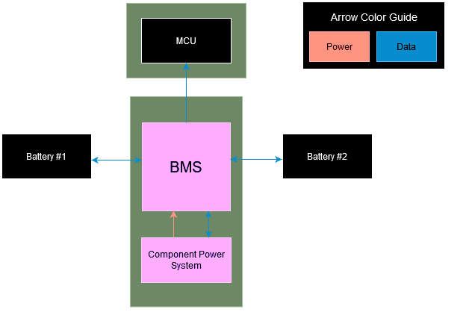

Diagram at the time of SRR

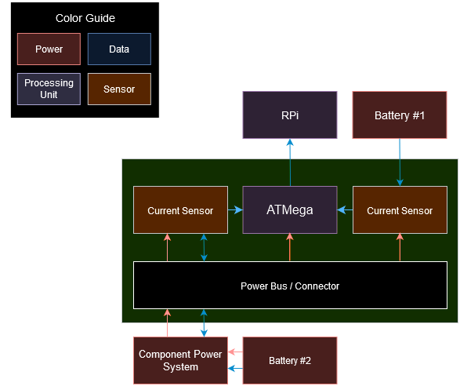

Diagram at the time of PDR

5.2 Power Board Block Diagram

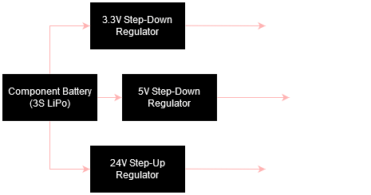

Diagram at time of SRR

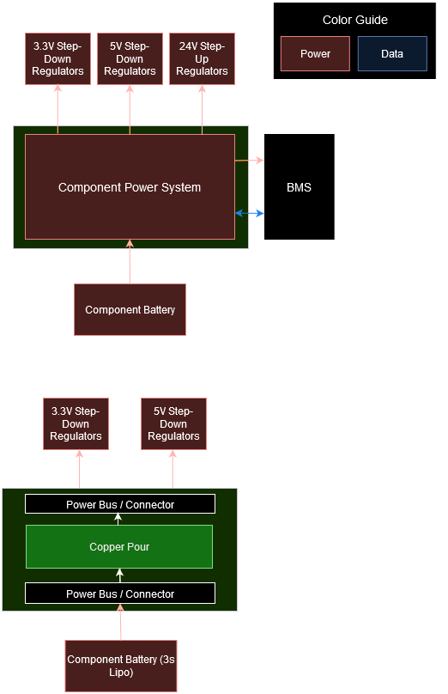

Diagram at the time of PDR

5.3 Signal Shields Block Diagram

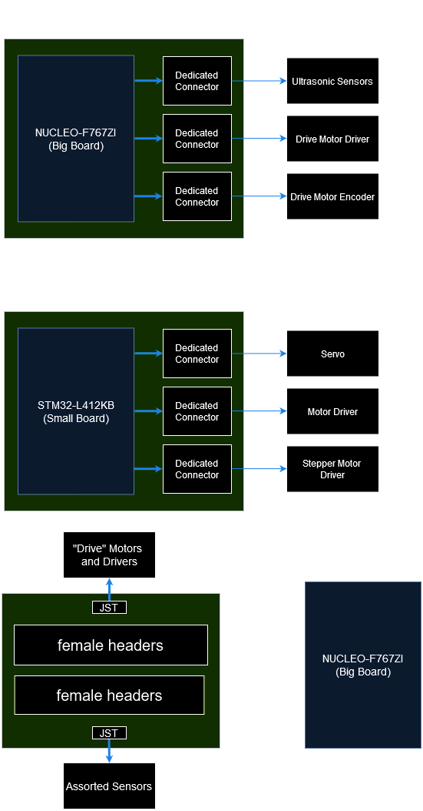

Diagram at the time of SRR



Diagram at the time of PDR

6. Voltage Regulators Board

Voltage Regulators would supply power to components and the microcontrollers of the vehicle. Specifically, we chose a synchronous switching buck regulator IC TPS54308 to design around. Design was split up into two teams: the Voltage Regulator team, who focused on design and simulation of the output filter of the IC, and the PCB team, who would create the board that the IC and supporting filter would sit on.

6.1 Version 1: Schematic, PCB Design, and 3D Model

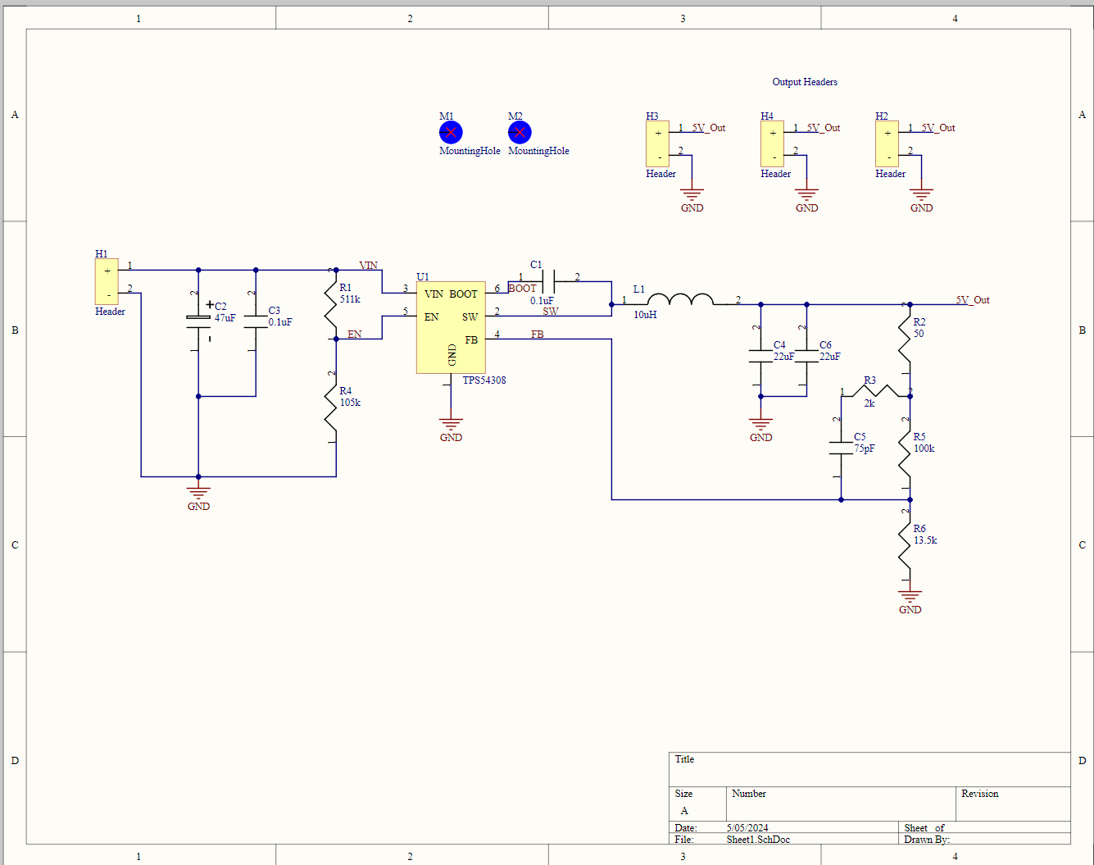

Altium schematic

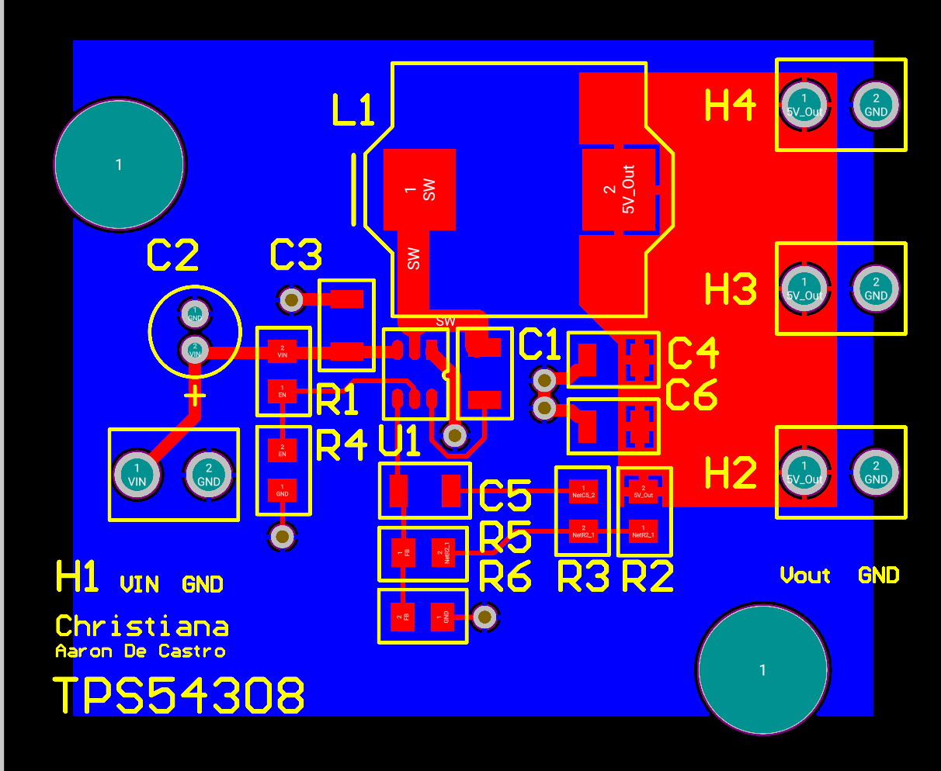

Altium PCB layout

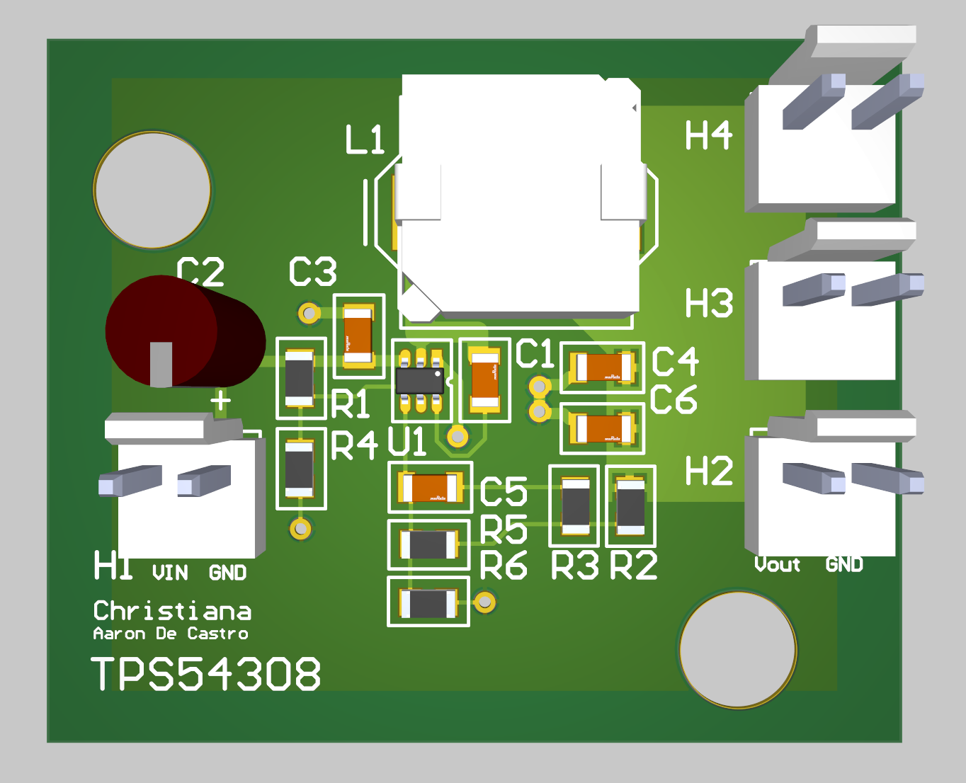

Altium 3D PCB model

6.2 Version 1: Testing/Results

[Voltage Regulator PCB testing results](https://livecsupomona-my.sharepoint.com/:x:/r/personal/aodecastro_cpp_edu/Documents/NGCP%20Electrical/Electrical%202023-2024/Regulator%20Team/Regulator%20Testing%20Data.xlsx?d=w1f981e7fb5a24a95997e148c466364a6&csf=1&web=1&e=0BS7Mr)

6.3 PCB Design Review Notes

1. Battery Management System Board

7.1 Schematic, PCB Design and 3D model

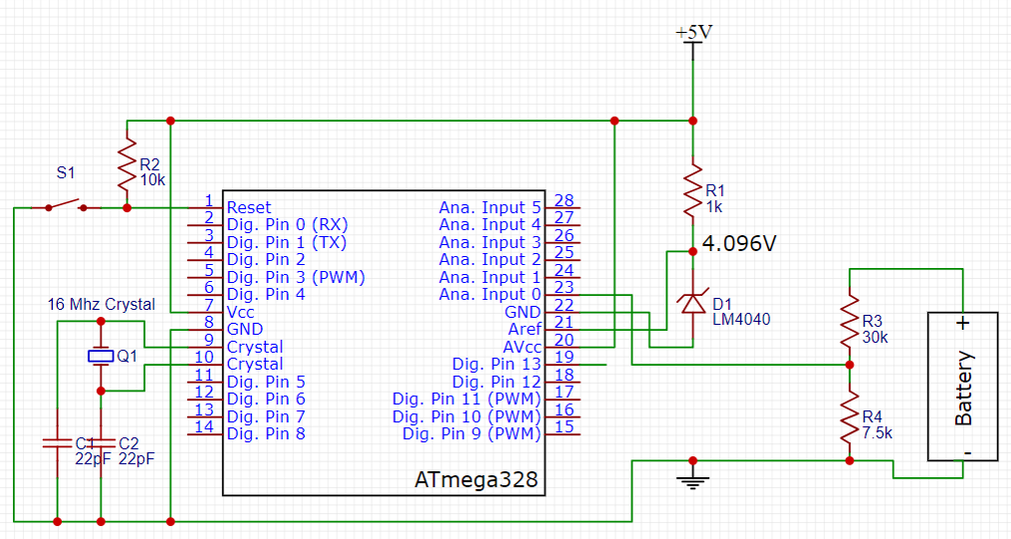Version 1 EasyEDA Schematic

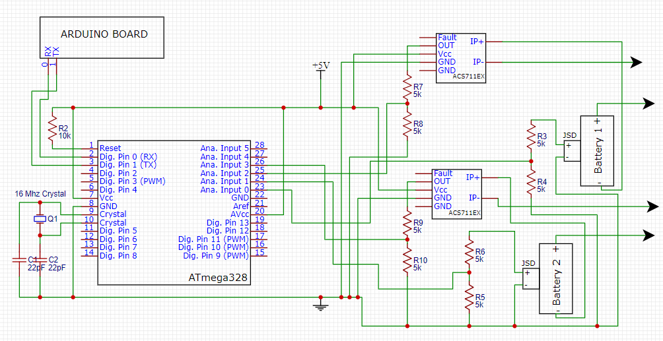Version 2 EasyEDA Schematic

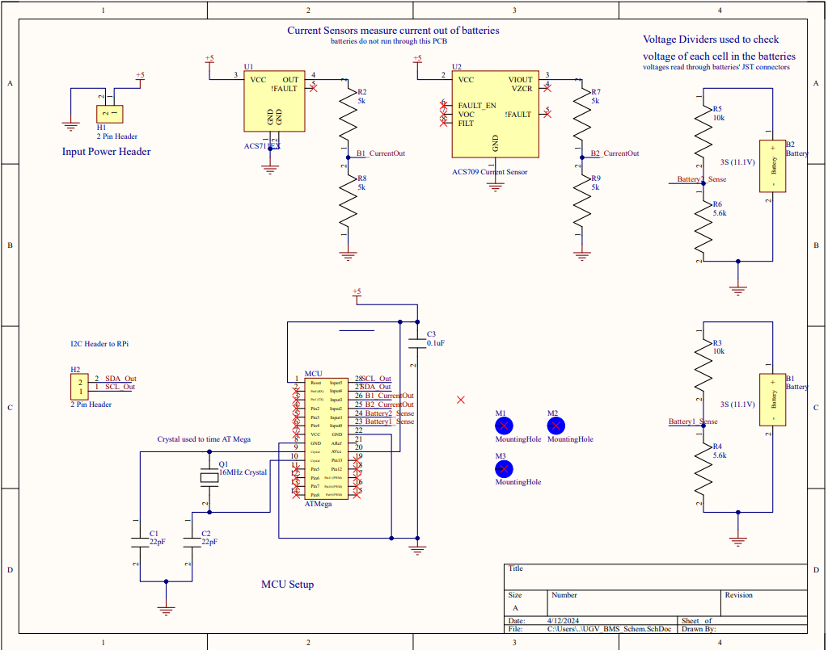

Version 2 Altium Schematic

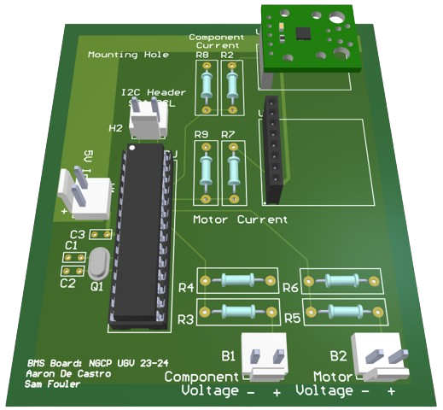

Version 2 Altium 3D Model

7.2 Testing/results

[Bootloading, Uploading and Layout doc](https://livecsupomona-my.sharepoint.com/:w:/r/personal/aodecastro_cpp_edu/_layouts/15/doc2.aspx?sourcedoc=%7B4fe14a44-6c02-4e3f-b144-4988b8a0937e%7D&action=edit) for testing

Burn Bootloader

Wire setup:

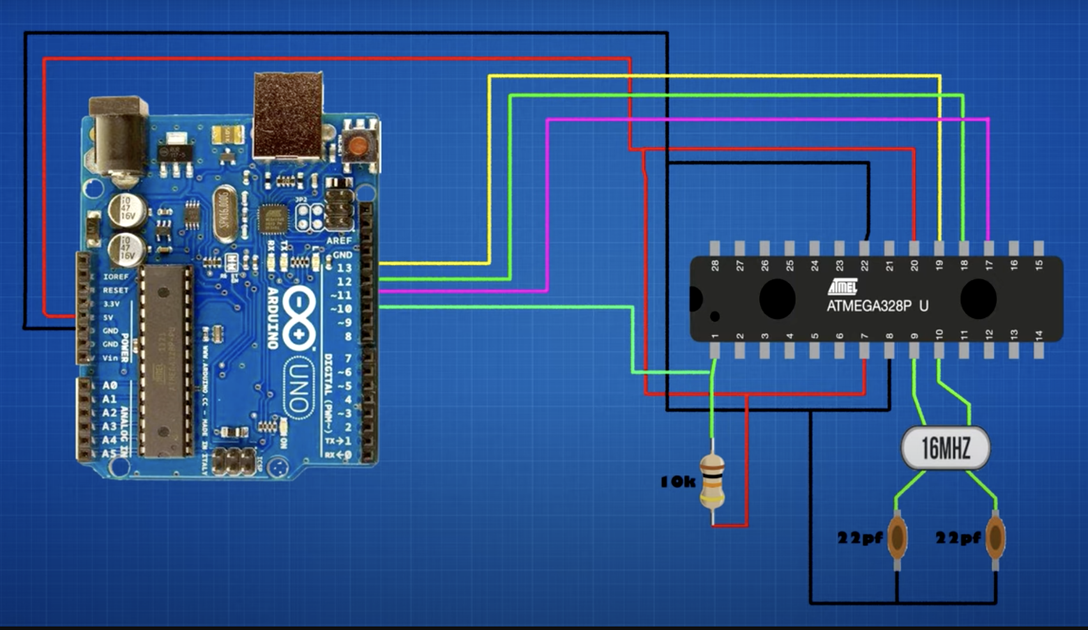

Remember there is an arduino chip in the uno:

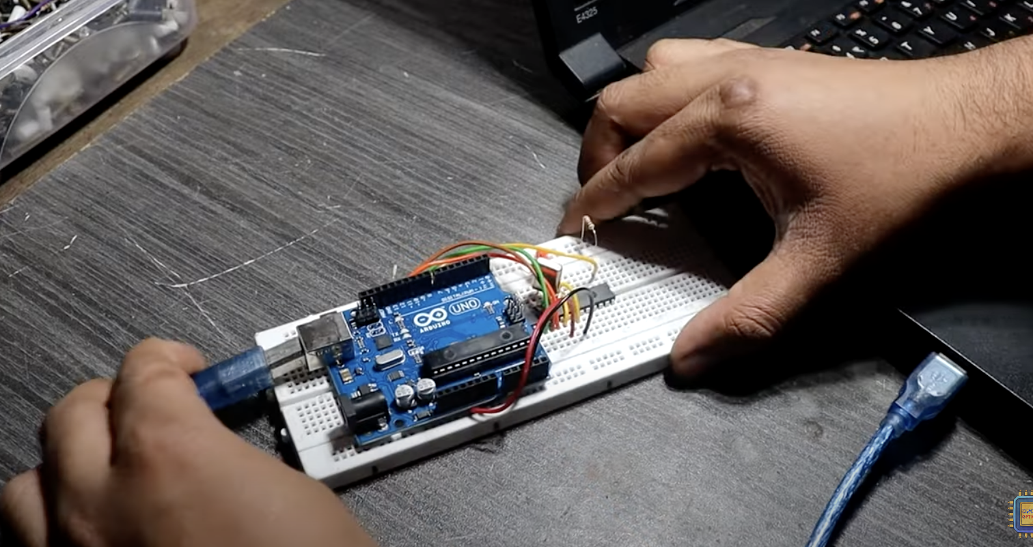

In arduion IDE steps

Step 1:

* Tools
  + Confirm PORT
  + Confirm Board: Arduino Uno
  + Change Programmer: ArduinoISP

Step 2:

* File -> Examples -> 11. ArduinoISP -> Click ArduinoISP
  + New ArduinoISP sketch will open up
* Upload Sketch

Step 3:

* Tools
  + Change Programmer: Arduino as ISP
* Tools -> Burn Bootloader

Video for further reference: <https://www.youtube.com/watch?v=B5HT5IKcprE>

Uploading Code through Uno

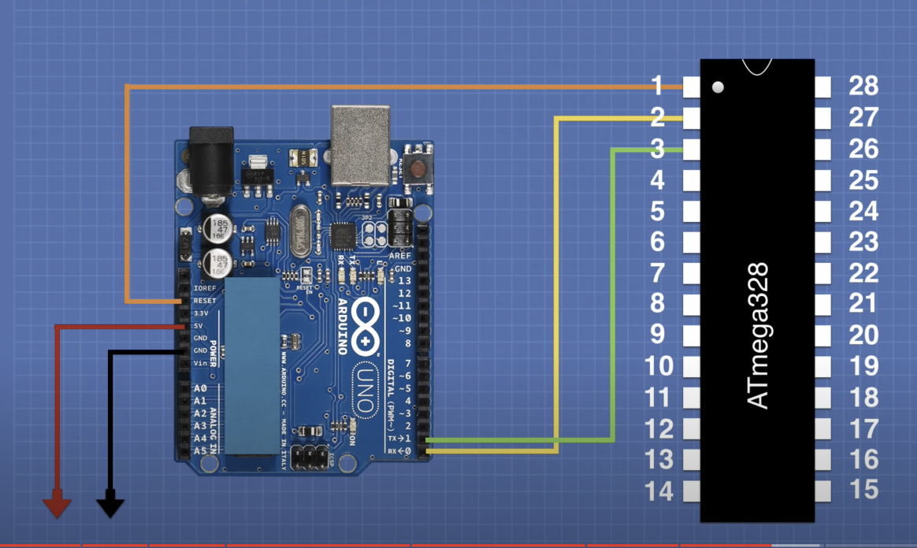

Make sure reset, RX and TX connections are made

<https://www.youtube.com/watch?v=Sww1mek5rHU&t=1435s>

BMS proto board layout and BMS PCB

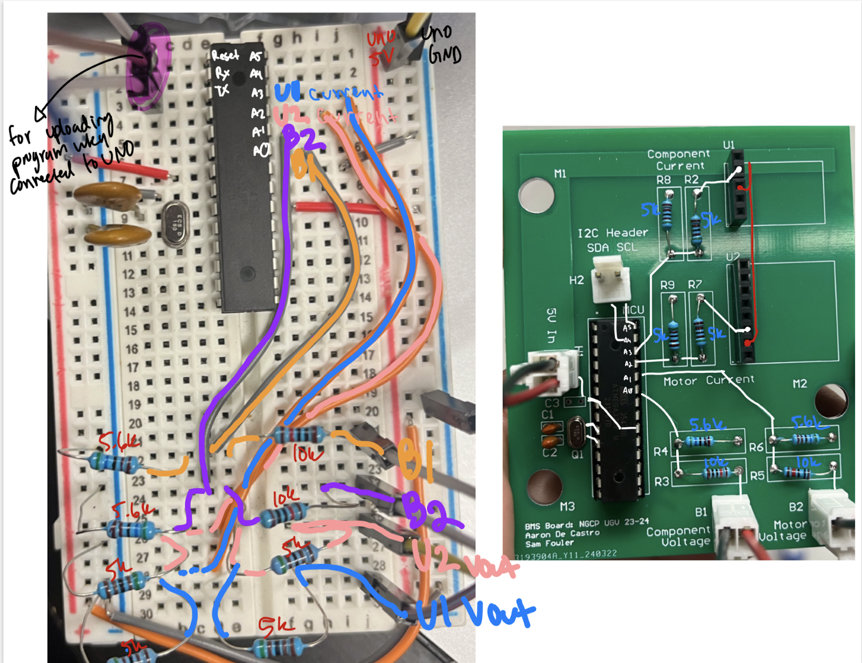

[Initial Testing log](https://livecsupomona-my.sharepoint.com/:w:/r/personal/aodecastro_cpp_edu/_layouts/15/Doc.aspx?sourcedoc=%7BF9877121-7EE3-4DA9-91A0-60CF57BE61B9%7D&file=Current%20Sensor%20Testing.docx&action=default&mobileredirect=true) doc

Testing some current sensors to implement Voltage Correlation with IR Correction into our BMS system.

Our Current Sensors on Hand:

ACS709 Current Sensor Carrier - <https://www.pololu.com/product/2199>

* +/- 75 amp current sense board
* Analog voltage as output, equation used to solve for current
* Has reference voltage pin

ACS711EX Current Sensor Carrier - <https://www.pololu.com/product/2452>

* +/- 15 amp current sense board
* Analog voltage as output, equation used to solve for current

Testing – Jan 4 2024

* To **test these modules**, we hooked up a LiPo battery to a charger and used the charging/discharging amperage to compare against the results we got from the sensor
* Oscilloscope used to measure output analog voltage
* DO NOT NEED GROUND OF COMPONENT TO BE SENSED TO BE CONNECTED TO SENSOR (isolated grounds)
* Tested the ACS709 first
  + First module we tested from last year was determined to be broken. The board carries a reference voltage pin that represents the quiescent voltage, or voltage when no current is flowing through the current sensor. However, when no current was flowing, the output voltage pin read 0 volts, meaning that the board was damaged.
  + The second module was working, however.
    - Vout pins and Vref pins displayed the same voltage with no current
    - However, no noticeable change in voltage was seen when load applied across. We believe it was a combination of the ACS709’s range being too wide (-75 to +75 amps) and our load current being too small to contribute to a meaningful change in Vout.
* Tested the ACS711EX next
  + Module was okay since quiescent voltage @ Vout was sitting at half of Vcc (expected)
  + Applied a 3A charging load to the battery, results were as follows:
    - Quiescent voltage: 2.656V
    - Vout while charging: 2.219V
    - 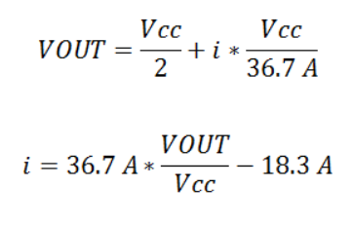 Equations for relationship between Vout and current
    - Vcc = 2.656*2 ~= 5.3V
    - Vout = 2.219V
    - Current = -2.93A, negative because charging instead of outputting
  + **Test worked, about 2% difference from actual and measured**

Schematic of Testing Platform

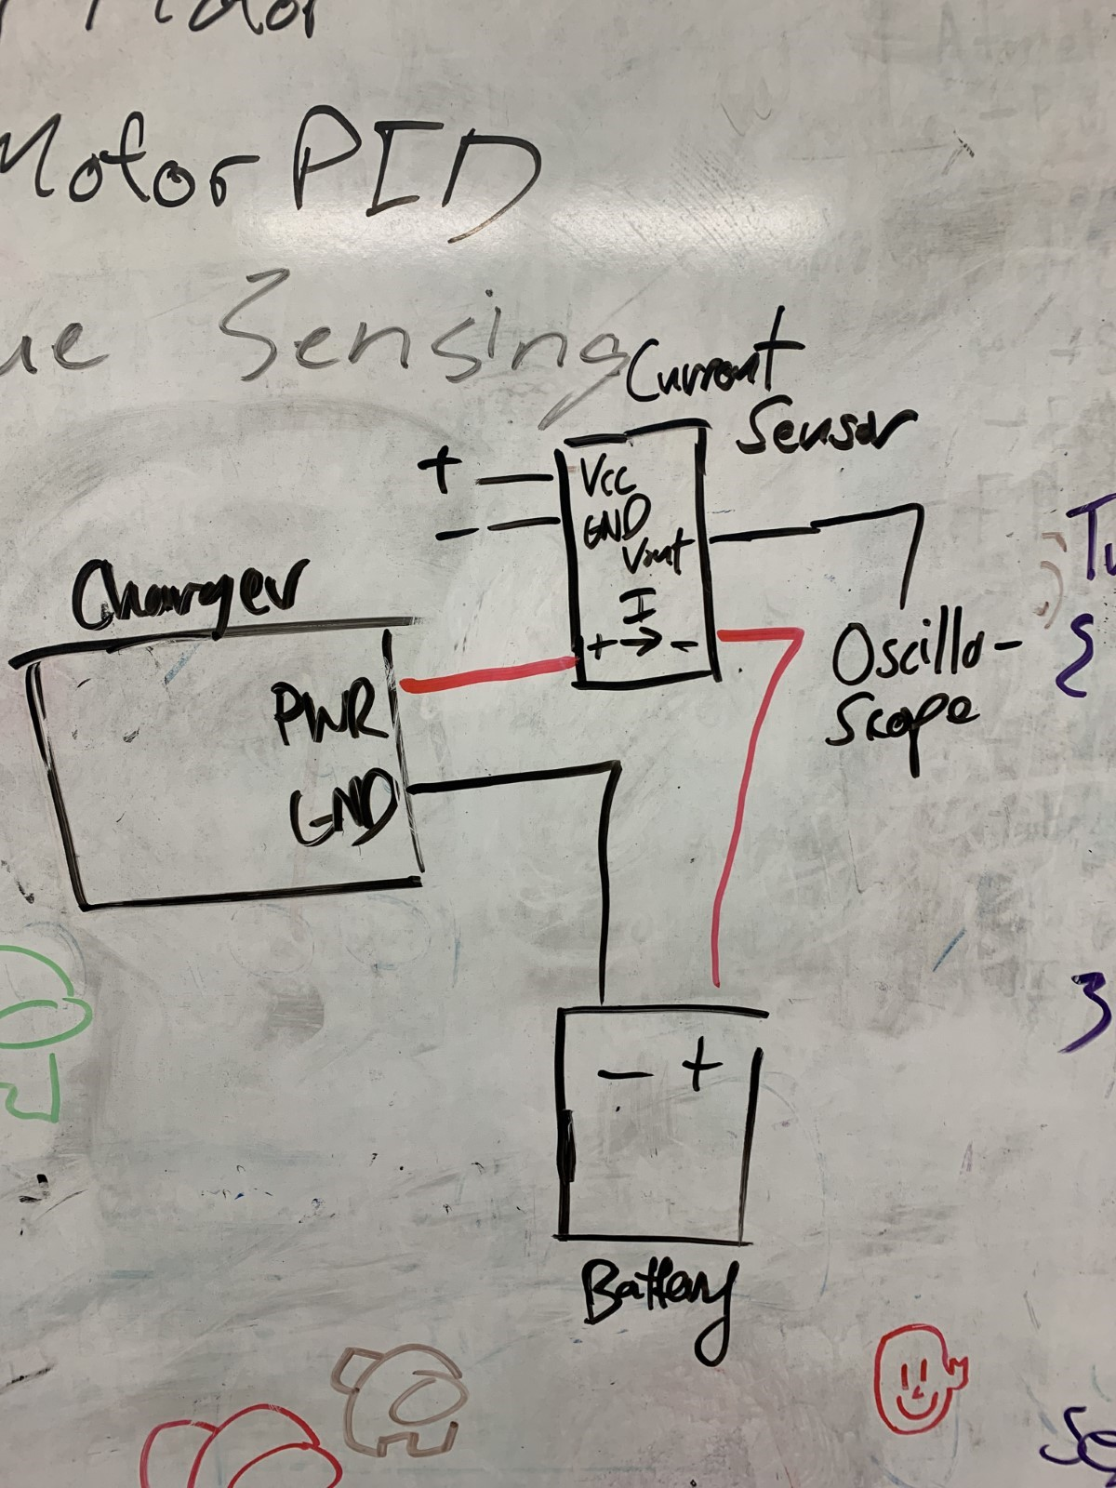

[Internal Resistence Lipo Testing Log](https://livecsupomona-my.sharepoint.com/:x:/r/personal/aodecastro_cpp_edu/_layouts/15/Doc.aspx?sourcedoc=%7B11B323E5-6A85-48DE-85AC-4A463AA45FD8%7D&file=3s%20Lipo%20Resistance.xlsx&action=default&mobileredirect=true) excel

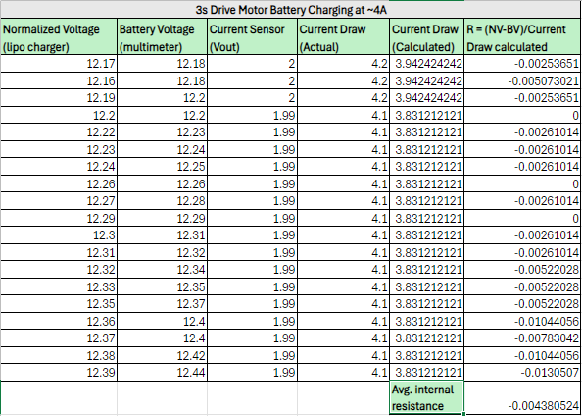

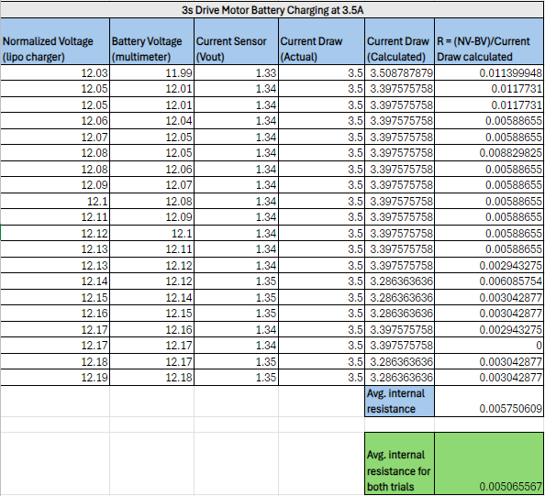

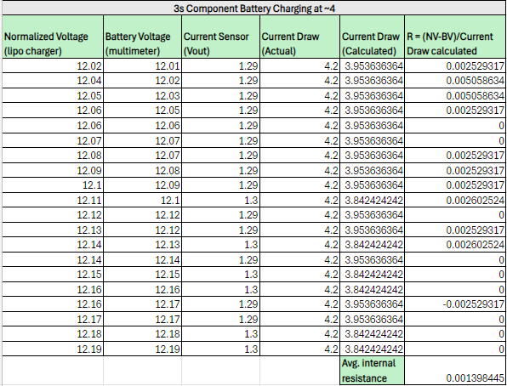

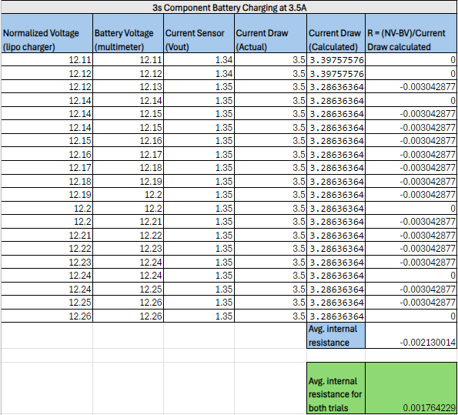

8. Power Board

8.1 Version 1: Schematic, PCB Design and 3D Model

a

8.2 Version 1: Testing/Results

a

9 Signal Shields

Three Microcontroller boards were used (STM32 Series-F767ZI, F302R8, L412KB) to perform as drivers and sensors for the UGV Vehicle. Both L4 and F3 boards operated simultaneously and communicated with the lead board F7 via I2C communication protocols. The F7 board communicated with the Raspberry Pi 4 board via USB2.0. Signal board shields were then drafted and turned into PCBs for each board used to help lessen unnecessary jumper wires between each board as well as making sure each connection was reliable. Each shield has a dedicated JST (Japan Solderless Terminal) connectors for each sensor

9.1 Version 1: Schematic, PCB Design and 3D Model

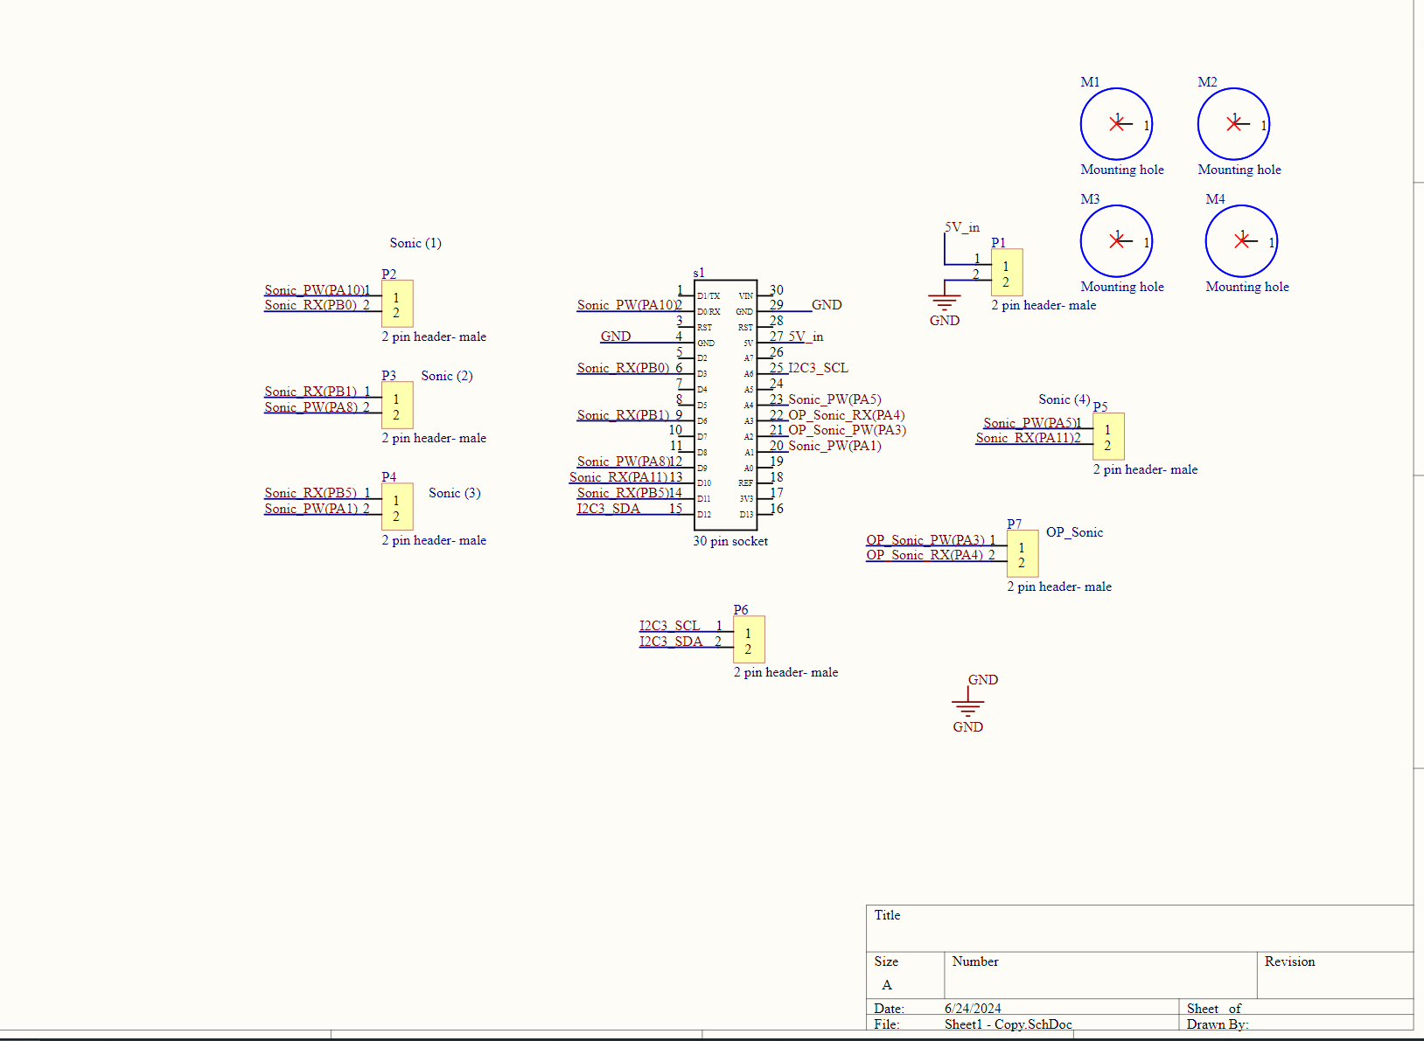

Altium Schematic for the L412KB shield

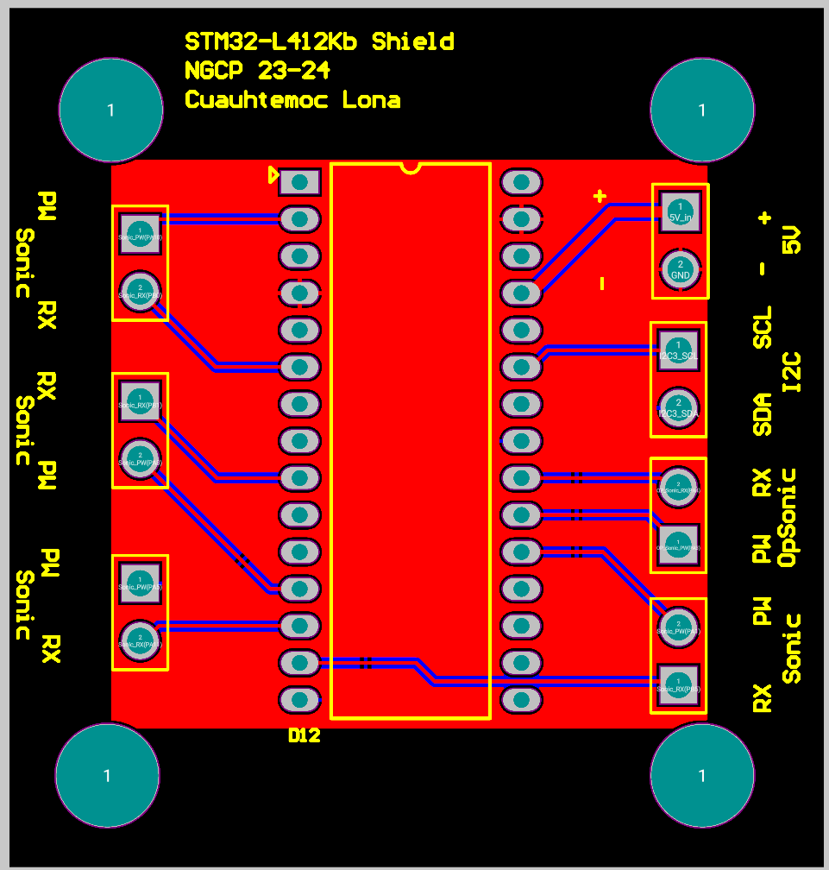

Altium PCB layout for the L412KB shield

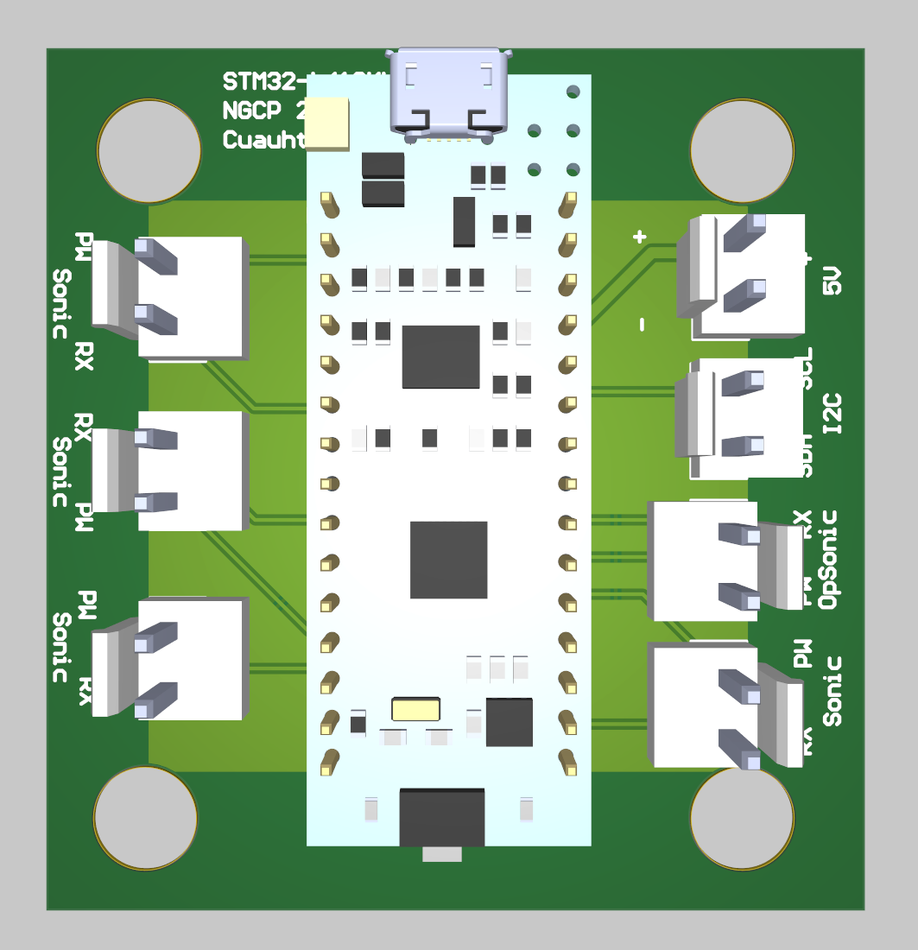

Altium 3D model for the L412KB shield

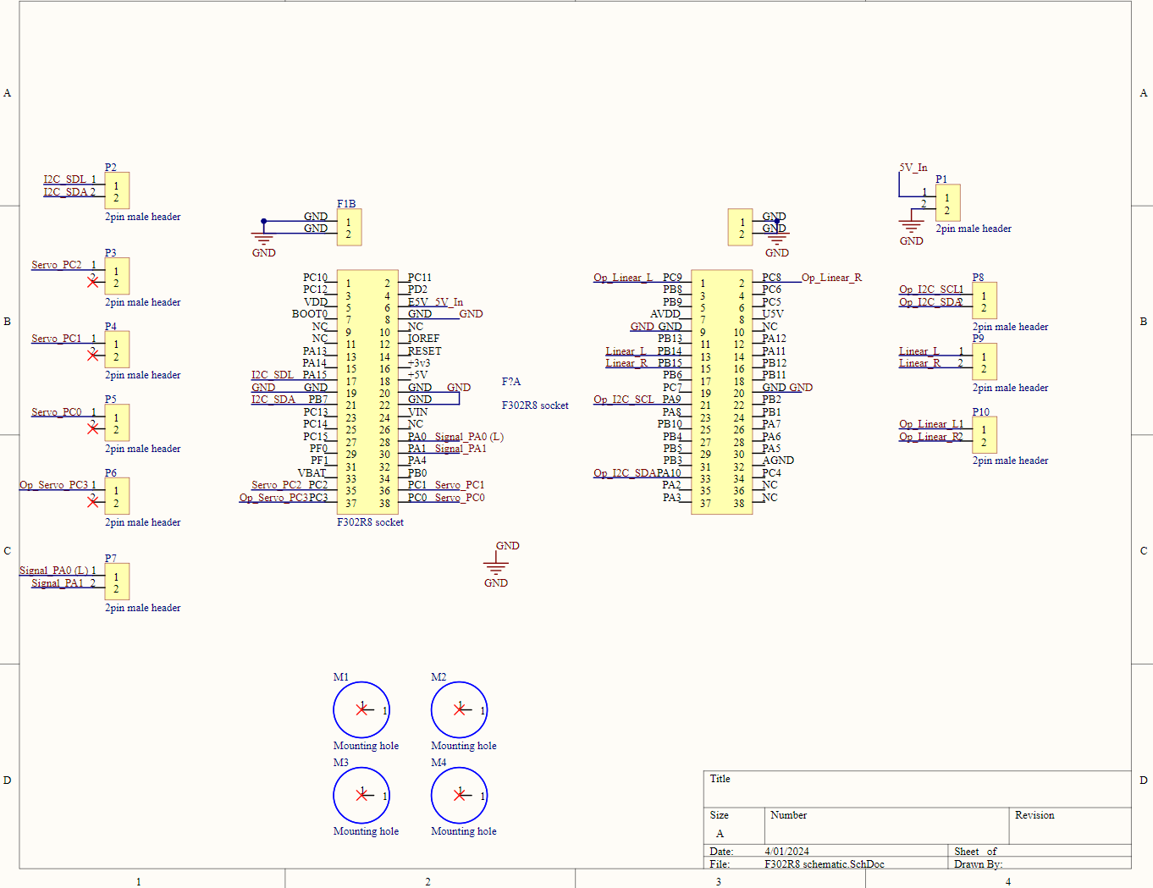

Altium Schematic for the F302R8 shield

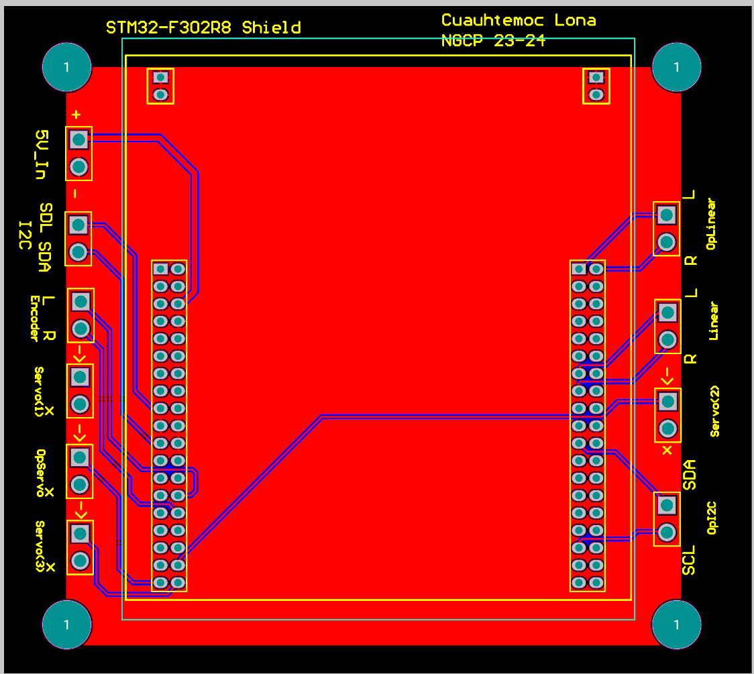

Altium PCB layout for the F302R8 shield

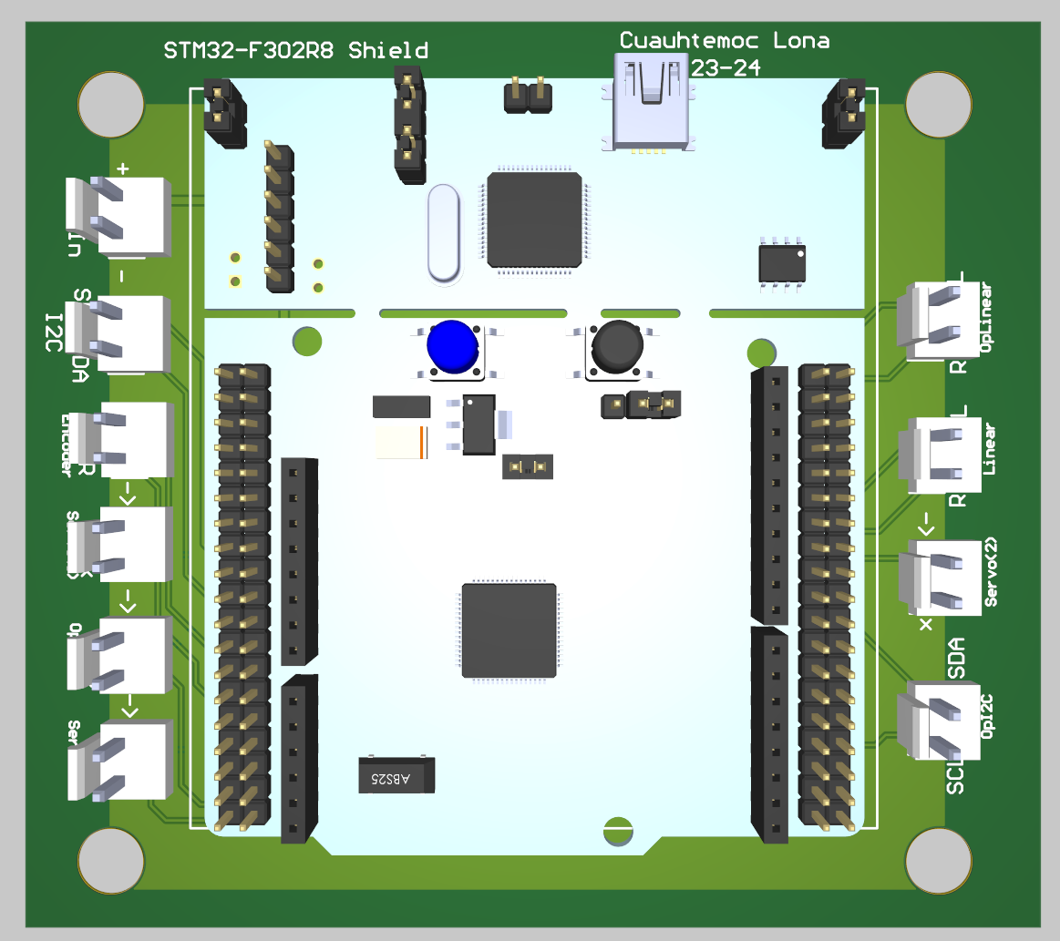

Altium 3D model for the F302R8 shield

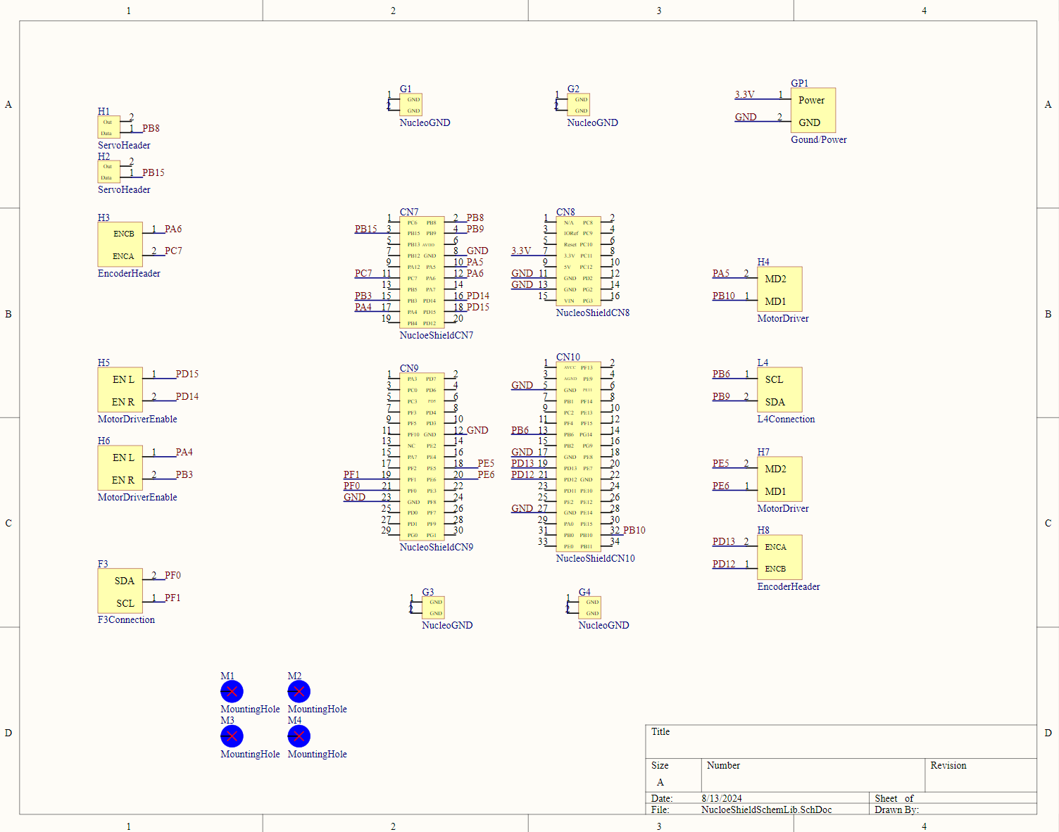

Altium Schematic for the F767ZI shield

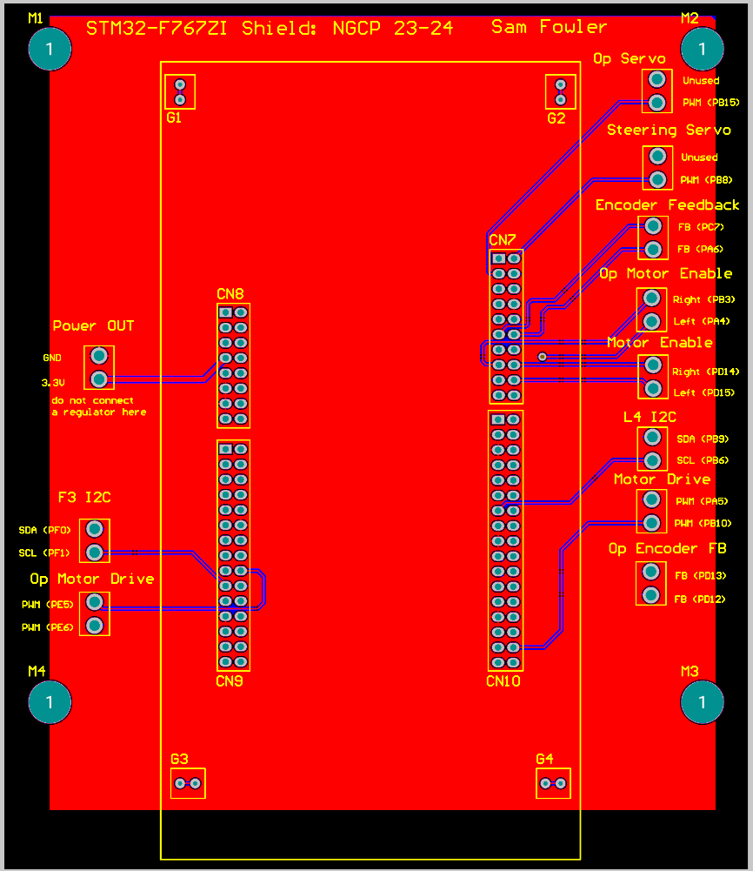

Altium PCB layout for the F767ZI shield

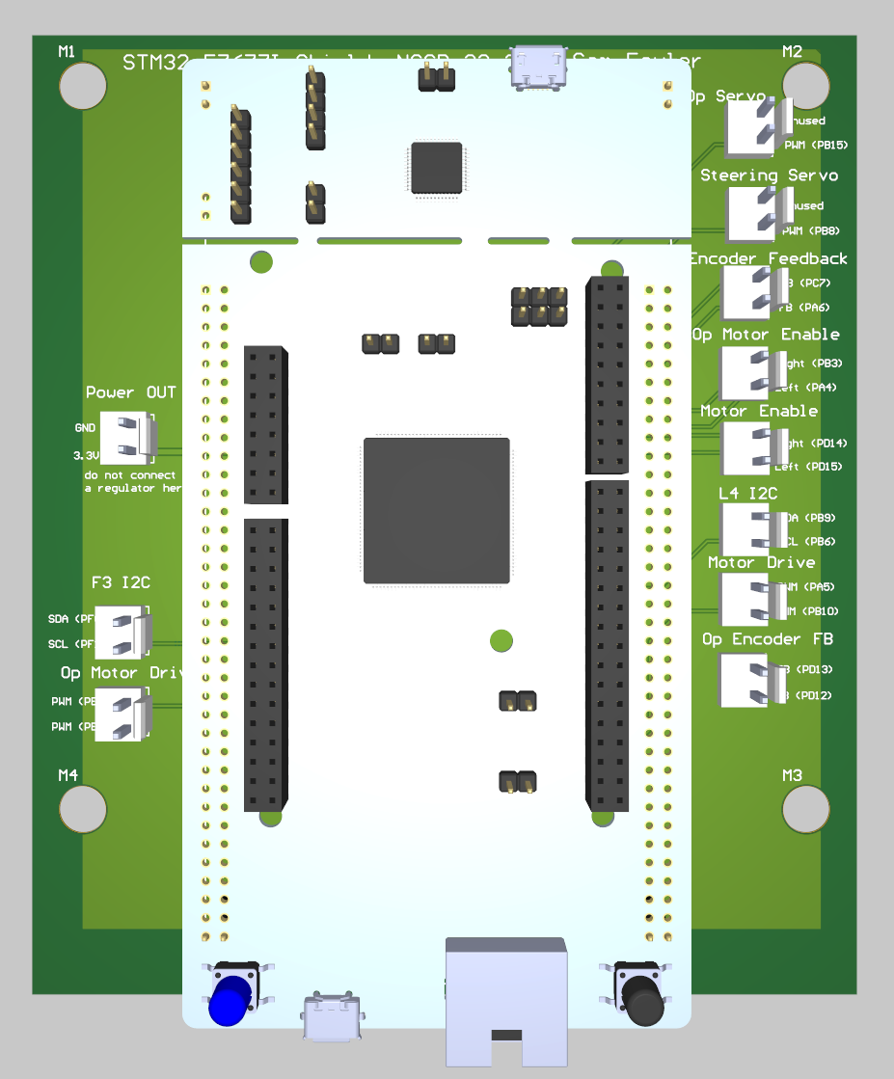

Altium 3D model for the F767ZI shield

9.2 Version 2: Testing/Results

Testing was conducted to see if connections were continuous. The results yielded that each board performed as expected.

10. Preliminary Design Review

[Electrical 2023-2024 -> Project Reviews -> PDR->pdr slides and templates](https://livecsupomona-my.sharepoint.com/:p:/r/personal/aodecastro_cpp_edu/_layouts/15/Doc.aspx?sourcedoc=%7B656C062A-D24C-42C1-9AC0-79C9E26D6ADA%7D&file=pdr%20slides%20and%20templates.pptx&action=edit&mobileredirect=true)

